10 Richest People of All Time
Source: http://wallstcheatsheet.com/personal-finance/the-10-richest-people-of-all-time.html/?a=viewall
You may feel that today’s obscenely rich — you know, the Bill Gates and Warren Buffetts of the world — have fortunes so vast that they could never be topped. Well, relatively speaking, the contemporary versions of the world’s wealthiest pale in comparison to those of the past, and by a wide margin.
There have been countless fortunes won and lost throughout history, both modern and ancient. People have built massive amounts of wealth a variety of ways, including ruling over empires, conquering neighbors, savvy investing, and building incredibly powerful businesses. Today, it seems as though many of the world’s wealthiest have built their mountains of money through business ventures or inheritance, but throughout history, the case is a bit more bloody.
So who are the richest people to have ever lived? Digging through research done by Business Insider, Celebrity Net Worth, and Yahoo Finance, we’ve been able to put together a list of the top 10 wealthiest individuals of all time. One important thing to note is that there are likely figures missing, as numbers do tend to get lost or disappear as time goes on. There are likely many historical figures — like Alexander the Great, Genghis Khan, King Solomon, numerous Roman emperors, Egyptian pharaohs, and popes — who have controlled huge fortunes, but there is no real way to put a figure on it. Powerful families exist as well, including the Rothschild and the Medici families; however, their wealth is spread across several individuals.
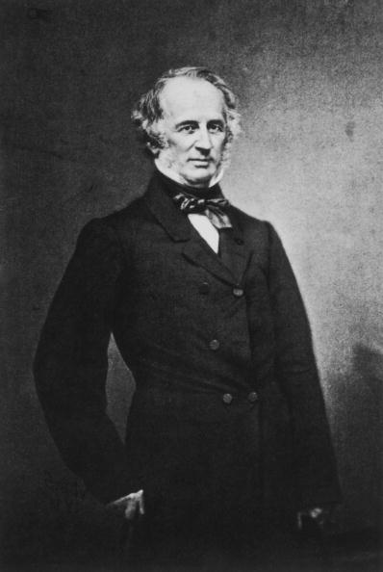
Ready to find out who exactly the richest people of all time were? Read on to see the top 10.
10. Cornelius Vanderbilt, $185 billion
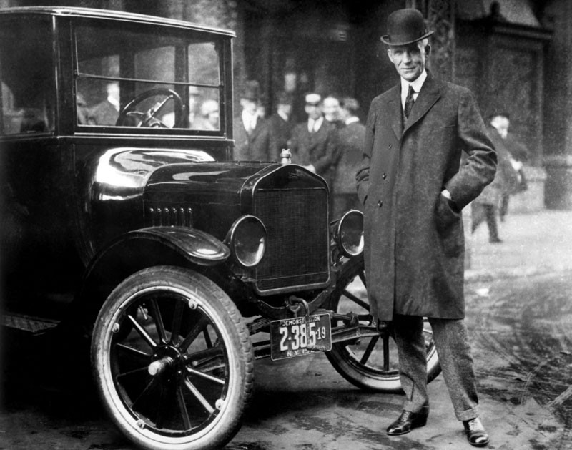
One of the most famous names in American history was built by Cornelius Vanderbilt, a man who came to fortune through the building of railroads and shipping lines during the 1800s. He is also the founder of Vanderbilt University, and his family name still carries much clout today. CNN anchor Anderson Cooper is even a part of the Vanderbilt family. During his heyday, Cornelius Vanderbilt’s wealth reached an approximate $185 billion, most of it accumulated later in life as he expanded his railroad empire following the Civil War.

Getty Images

9. Henry Ford, $199 billion
One of the major figures in American business history, Henry Ford was able to put together a net worth totaling just under $200 billion. Ford, of course, is known for founding Ford Motor Co. and bringing automobiles to the masses. A transportation revolutionary, he also was a trailblazer in industry and business, instituting higher wages for his workers and developing the concept of the assembly line, which allowed for the manufacture of inexpensive goods that the masses could afford.
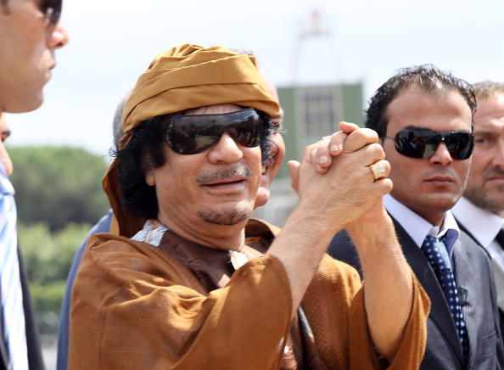
Ernesto Ruscio/Getty Images

8. Muammar Gaddafi, $200 billion
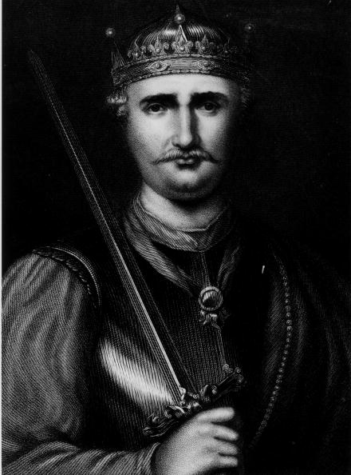
One person who most readers are likely familiar with is Muammar Gaddafi, the recently deceased and overthrown ruler of the northern African country of Libya. Gaddafi is said to have controlled a vast fortune of $200 billion, amassed during his 42-year rule over Libya. A highly controversial and divisive politician and ruler, Gaddafi was famously overthrown in 2011 during the Libyan civil war, when he was dragged into the streets and killed by revolutionaries.

Hulton Archive/Getty Images

7. William the Conqueror, $209 billion to $229 billion
William the Conqueror’s wealth has been estimated to be between $209 billion and $229 billion. Best known for becoming the first Norman king of England, William reigned from 1066 until 1087. He led the final successful invasion of England, becoming a monarch after setting out to depose of one. He was also known as William the Bastard and is thought to have been a descendant of viking invaders from years before, which explains where he got his knack for invasion.
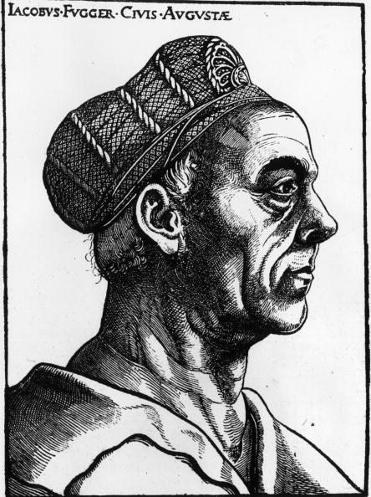
Hulton Archive/Getty Images

6. Jakob Fugger, $221 billion
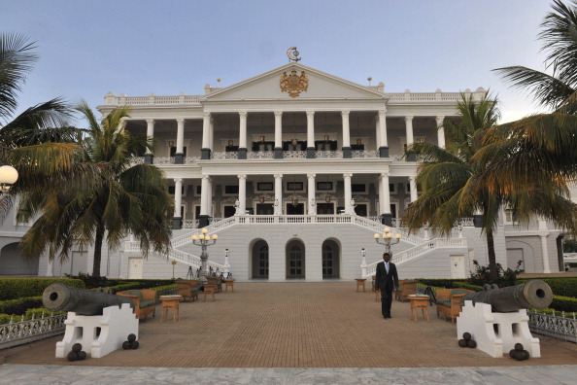
A relatively obscure historical figure compared to many other members of the world’s wealthiest, Jakob Fugger nonetheless was able to hoard $221 billion through his merchant and banking activities. Fugger lived from 1459 until 1525, having been both born and dying in Augsburg, Germany. The Fugger fortune was made through textile trading in Italy mostly, but also through the mining of silver and gold in Hungary and Bohemia.
Noah Seelam/Getty Images

5. Mir Osman Ali Khan, $230 billion
You may never have heard of Mir Osman Ali Khan, but he was without a doubt one of the wealthiest people the world has ever known. As ruler of the Hyderabad State in India, he grew his riches to a total of $230 billion. He became Nizam of Hyderabad after his father died in 1911 and reigned for 37 years, overseeing the expansion of education, electricity, and railroads in the region. He died in 1967, survived by his reported 149 children.
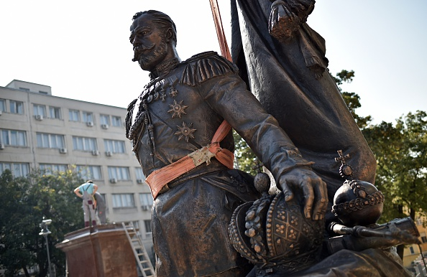
Andrej Isakovic/Getty Images

4. Nikolai Alexandrovich Romanov, $300 billion
Known as Tsar Nicholas II, Nikolai Alexandrovich Romanov amassed $300 billion worth of wealth during his tenure. Nicholas II is probably most famous for being the last emperor of Russia before the country fell during the Russian Revolution. Both he and his family were eventually executed in 1918. Notably, Nicholas II became a saint recognized by the Russian Orthodox Church, and is known as the wealthiest saint in human history.
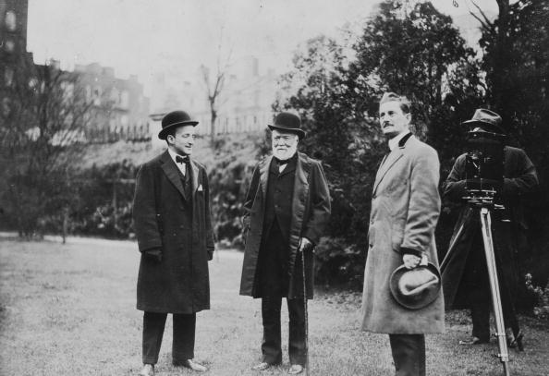
Hulton Archive/Getty Images

3. Andrew Carnegie, $310 billion
Andrew Carnegie, an incredibly wealthy and powerful industrialist, came to prominence during the mid-1800s by way of the steel industry. Having been born in Scotland, Carnegie came from a very poor family that entered the United States in the late 1840s. After successfully investing in a number of ventures, Carnegie founded the U.S. Steel Corp., which earned him most of his $310 billion fortune. He is also known for giving away almost all of it, and is remembered as one of the world’s foremost philanthropists.
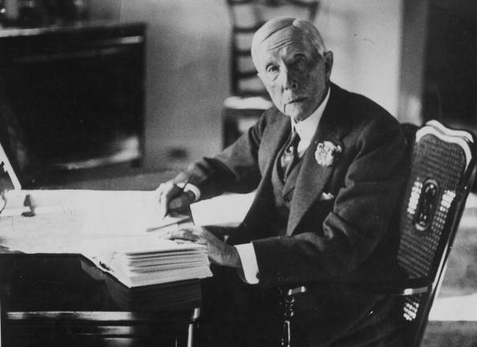
Hulton Archive/Getty Images

2. John D. Rockefeller, $340 billion
The Rockefeller name is deeply ingrained in American history, and John D. Rockefeller’s $340 billion fortune still stands today as nearly the largest the world has ever seen. Born in 1839 in New York, he grew to prominence over his lifetime as the co-founder of Standard Oil. As one of the revolutionaries of the energy and petroleum industries, Rockefeller is also well known for his philanthropy, founding two colleges during his lifetime, the University of Chicago and Rockefeller University. He died in 1937 at the age of 97.
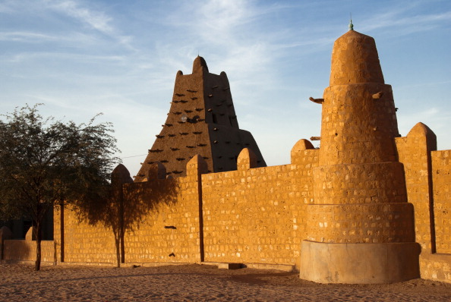
Jordi Cami/Getty Images

1. Mansa Musa, $400 billion
Far and away the richest man to ever walk the face of the Earth was Mansa Musa, or Musa I of Mali. As the reigning emperor of the Mali empire, Musa commanded a fortune worth a jaw-dropping $400 billion. That’s worth more than four times the current richest person in the world, to put things in perspective. Musa was born in 1280 and lived until 1337 as a devout Muslim, constructing numerous educational centers and mosques across Africa, one of which can be seen above, in Timbuktu. Being as that Musa’s reign was so long ago, there are still varying reports about his death and abdication of the throne to his son. However, no one has been able to come even close to the amount of wealth Musa presided over.

