AG-1 Ancient Greek Geography Name _________________________

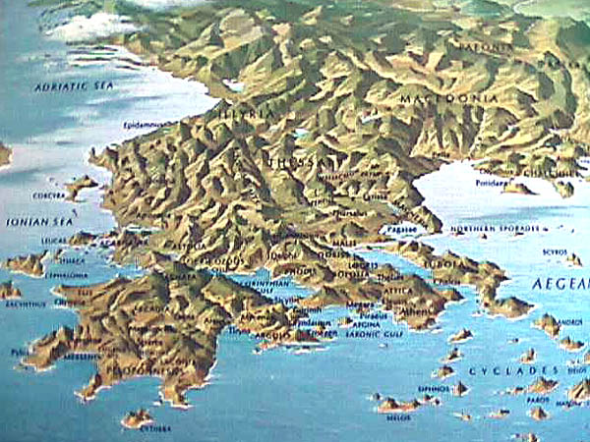
Around 600 BC a civilization was beginning, along the northeastern shores of the Mediterranean Sea. This civilization was that
of the ancient Greeks.

In Greece, there was no great river carrying layers of fertile silt to create rich farmland.
Instead of finding themselves in an environment provided by a river valley, ancient Greeks found themselves on a peninsula, a piece of land almost entirely surrounded by the sea, with a rocky landscape and few natural resources.

Mountains and hills cover nearly three-fourths of Greece. Western Greece is the most mountainous and travel by land is very difficult. The land is not very fertile, but farmers
herd goats and sheep on the rugged hillsides.

Eastern Greece has more land suitable for farming. Some of these farmlands are on the peninsula of Attica. Attica also has excellent natural harbors, or sheltered places, for ships.
The Peloponnesus, a large peninsula southwest of Attica, is a mountainous region
outlined by a thin area of fertile soil. This region includes several rivers, but they dry up
in the summer.

The climate of Greece also presented a challenge for early farmers. Summers were hot and dry, and winters were wet and windy. Ancient Greeks raised crops and animals well suited to the environment. Wheat and barley were grown, and olives and grapes were harvested. The many hills and mountains provided shrubs to feed the herds of sheep, goats, and cattle.

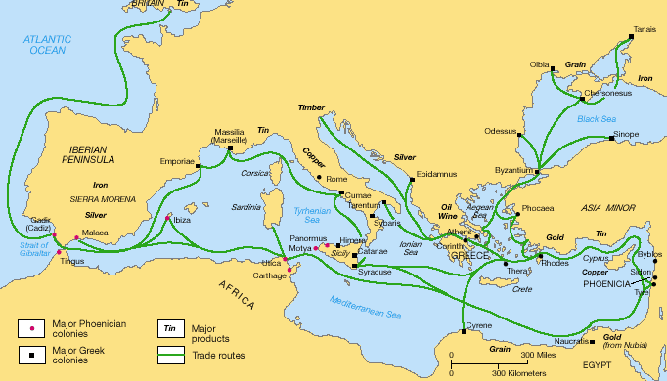
Because farming didn’t produce huge surpluses, and travel across the terrain was difficult, the Greeks came to depend on the sea. They became fishers, sailors, and merchants. Because of Greece’s location in the eastern Mediterranean, it was a perfect location for trade. Greek sailors were highly skilled, and traveled as far as ancient Egypt to trade their products.

Greek merchants competed with traders from other Mediterranean cultures. One of these cultures was the Phoenicians. Traders from all over were eager to exchange their goods for Greece’s olive oil, wool, and wine. Those who traded with the Greeks especially prized Greece's olive oil. It added flavor to food, and was useful as a lamp fuel and body lotion.

Cause and Effect

Answer the following questions from the reading. Then complete the graphic organizer.

1. What physical features make up nearly three-fourths of Greece?
_____________________________________________________________________
_____________________________________________________________________

2. How does such an environment affect life there?
_____________________________________________________________________
_____________________________________________________________________

3. What effects did geography have on the ways ancient Greeks met their needs?
_____________________________________________________________________
_____________________________________________________________________
_____________________________________________________________________

4. How did the limited amount of fertile land cause the Greeks to become sea traders?
_____________________________________________________________________
_____________________________________________________________________

5. Use context clues to define peninsula - _________________________________________

6. Use context clues to define harbors - _________________________________________

CAUSES EFFECTS
Many mountains

Thin, rocky soil

Climate of hot, dry summers and wet, windy winters

Location at the eastern end of the Mediterranean Sea

Ancient Greece Writing Prompt & Checklist

Write a one-paragraph summary to explain how the geography of
Greece influenced the ancient Greeks to become sea traders.

Your summary must:
_____ present the information clearly and be accurately organized.
_____ contain the main idea plus the most significant details.
_____ contain a topic sentence and supporting details
_____ include examples of cause and effect.
_____ use your own words.

