Ancient Africa Review Guide

Name: __________________________

Date: ____________ Core: __________

Date: _______________ Core: _______

**PART I. Identification**

**Complete the following terms. (Use your notes from the PowerPoint and text)**

1. Savanna _________________________________________________________________________
2. Mansa Musa ______________________________________________________________________
3. Aksum ___________________________________________________________________________
4. ­­­Griots ____________________________________________________________________________
5. Bantu ____________________________________________________________________________
6. Sahel_____________________________________________________________________________
7. Salt & Gold Trade___________________________________________________________________
8. Sundiata __________________________________________________________________________
9. Islam _____________________________________________________________________________
10. Folktales_________________________________________________________________________________

**PART II. Mapping**

**Identify the following features on the map of Africa**.

Nile River

Niger River

Congo River

Kingdom of Mali

Aksum

Nubian Kingdom

Sahara Desert

Timbuktu

**Legend:**

= River = Kingdom = Other

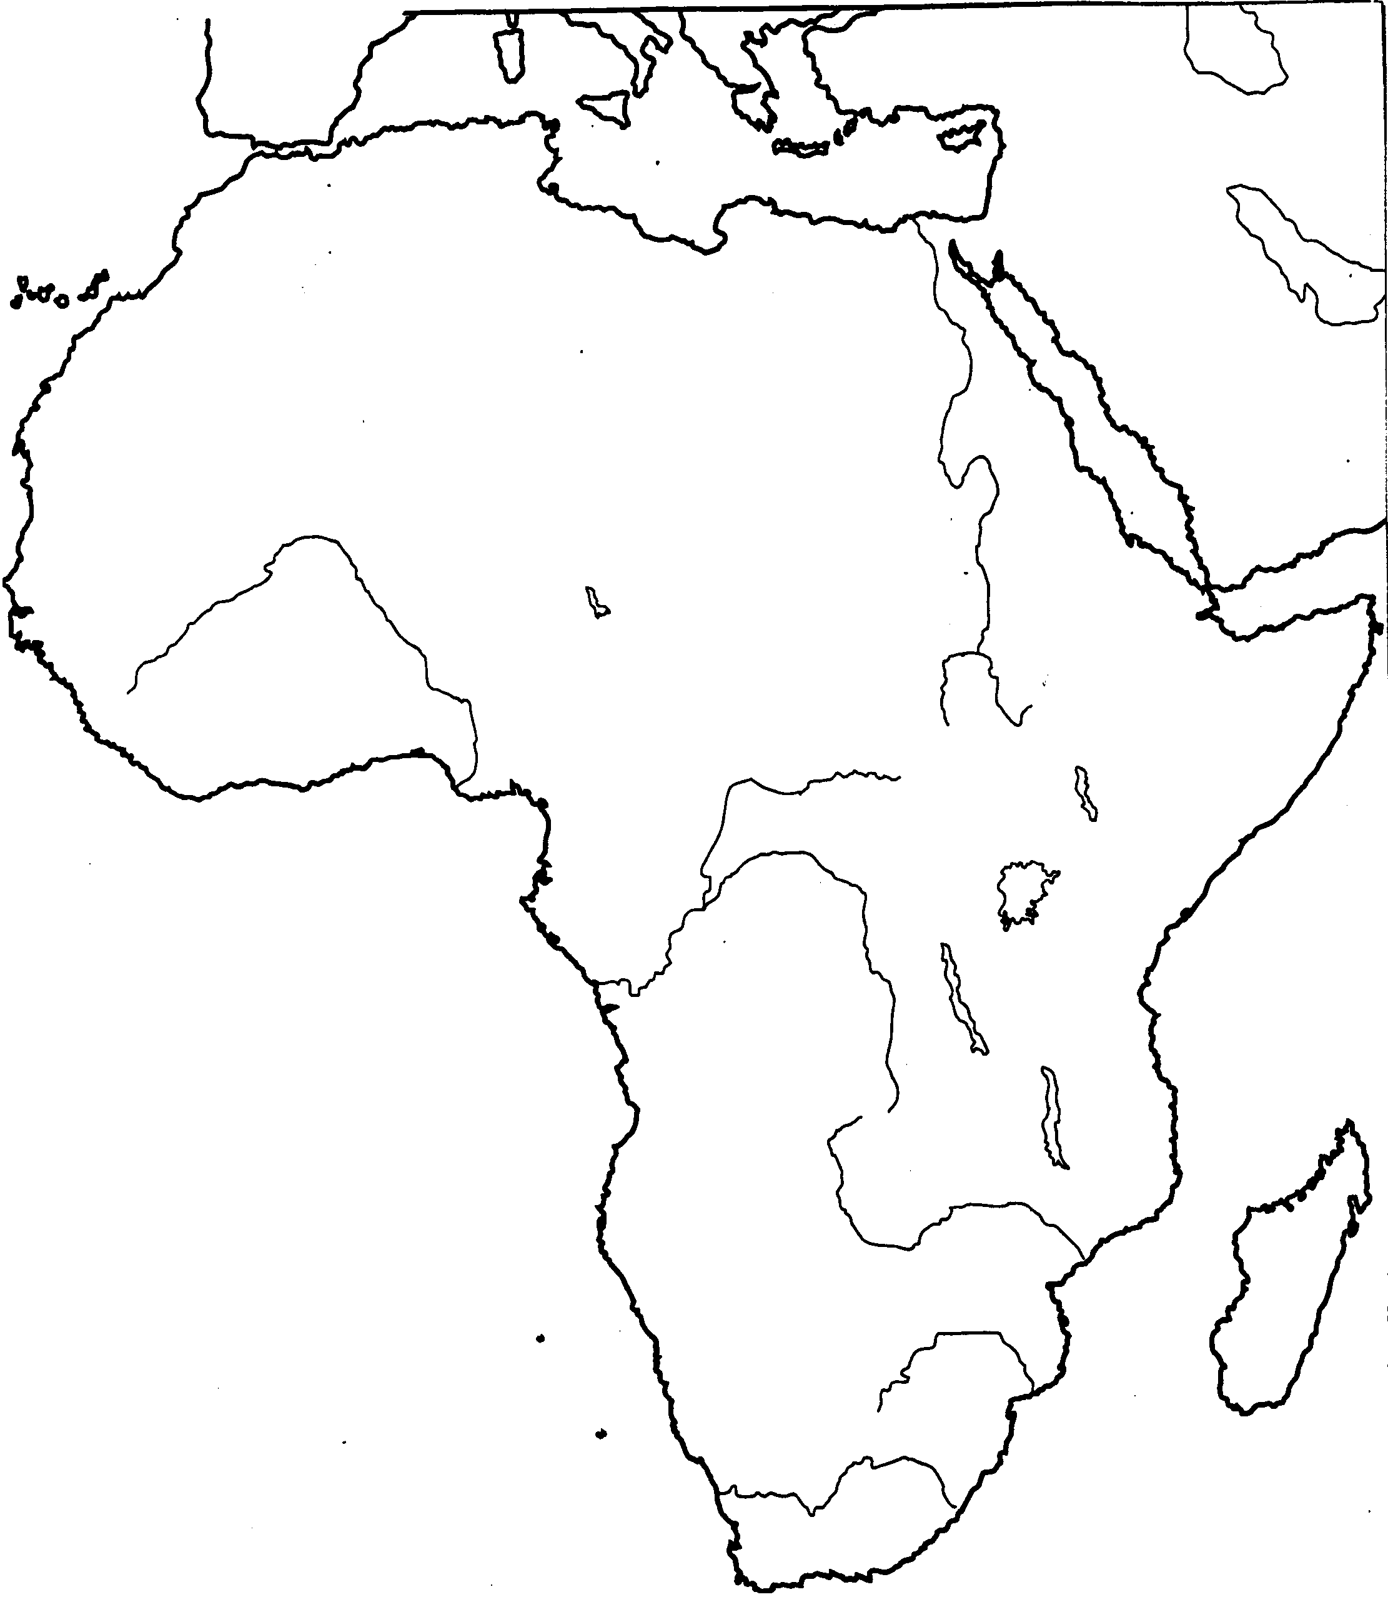

**PART III. Multiple Choice**

1. Describe the major kingdom that had control of major routes of the Trans-Saharan trade of salt and gold in 830 until c. 1235.

_____________________________________________________________________________________________________________________________________________________________________________________________________________________________________________________________________

1. Describe the fall of the empires of Ghana, Mali, and Songhai.

_____________________________________________________________________________________________________________________________________________________________________________________________________________________________________________________________________

1. Explain how Great Zimbabwe gained control of the gold trade.

_____________________________________________________________________________________________________________________________________________________________________________________________________________________________________________________________________

**Part IV: Primary Source**

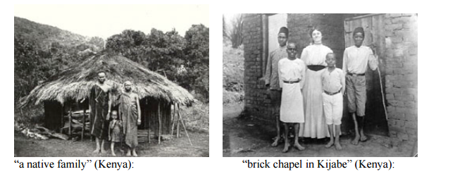

Use the primary source above to explain how European colonization impacted Africa.

___________________________________________________________________________________________________________________________________________________________________________________________________________________________________________________

___________________________________________________________________________________________________________________________________________________________________________________________________________________________________________________