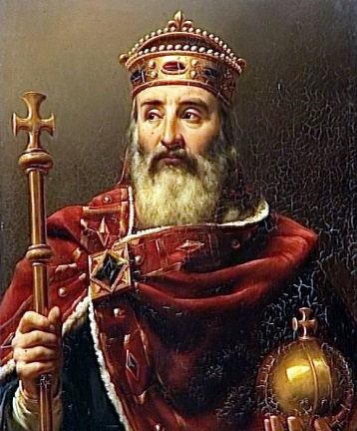
King Charlemagne (AKA Charles the Great)
Charlemagne was one of Medieval Europe's most famous Kings. He became king of the Franks at age 26, in 768 CE, when his father died. He inherited his kingdom from his father, Pepin the Short, who had inherited from his grandfather, Charles Martel, also known as Charles the Hammer. Pepin and Charles Martel were good kings, but Charlemagne was a far better one, and much more colorful. His subjects loved to brag about him!
He was over 6 feet tall, with long blonde hair that seemed to glow in the sun. He was always seen laughing, joking, or singing. Charlemagne was not one to sit on a throne and rule. He was always roaming about, either in one of his castles or through the countryside. He never just plain walked, He always strode. His dogs were his constant companions, playing and barking, wherever he went. If you wanted the king to do something, you had to walk with him. Charlemagne was reputed to have a great memory. He always addressed everyone by name. He seemed to know everyone from the top princes down to the lowliest peasant.
Charlemagne always led his troops into battle. He always wore a bright blue cape over his armor so that he could be easily seen. He was a great warrior and even though he fought in many battles he managed to survive them all and live into his seventies. Since most people died much younger during the medieval times this was another wonder and part of his mystique.
Expansion: The Franks were a great warrior tribe. Charlemagne and the Franks defeated most of the other tribes in Europe and expanded the Frankish Empire to cover Germany, France, Italy, and parts of Spain. This also included Belgium, Holland, Luxembourg and Denmark.
Trial by Ordeal / Trial by Jury: One of the most important things Charlemagne did for his people was do away with the old system of trial by ordeal and replaced it with trial by jury in place of trial by ordeal.
Education & Preservation: Another change Charlemagne introduced was his learning center at his main castle. Charlemagne brought scholars from all over the world to his new learning center. He put them to work teaching others how to read and write. He also had them copy all the old manuscripts he could find. During this copying, a system of illustrating and painting with gold foil was developed. These copies were known as illuminated manuscripts. Charlemagne could read, but he could not write. His fingers were too gnarled and battered from war to hold a pen. He used to keep writing materials under his pillow. When he couldn't sleep, he would practice writing, hoping to exercise his fingers enough to hold a pen, without success. He also opened schools around his empire. Many of the sons of nobles who were sent to these schools thought they would not have to work very hard. They were wrong! Charlemagne himself visited his schools and saw to it that the boys realized they had a great deal of work to do.
Government: Charlemagne created a new system to rule the huge empire he had created. He created a new class of Nobles called counts. Each count was responsible for his district (usually the size of a small country). The counts ruled in the name of Charlemagne. To ensure that the counts were ruling wisely Charlemagne made surprise visits to each of them at least once a year and sometimes more.
Standardized Money: Each count appointed tax collectors to collect the yearly taxes. The amount of the tax was set based upon the population. Everyone knew how much tax they owed. But there was a problem. Since most people paid their taxes through barter, the local tax collector could set the value for the barter. Charlemagne came up with a better system. He created silver coins, each with a set value to use instead. Thus a farmer could sell his crops for silver coins and then pay his tax with the silver coins. There was no way to cheat on this. Everyone, especially the peasants, loved the new system.
Name 3 significant facts about Charlemagne that all kids should remember.
- ___________________________________________________________________________________________
- ___________________________________________________________________________________________
- ___________________________________________________________________________________________

