Name___________________ Date____________Block_____
Decimal Study Guide
Adding, Subtracting, Multiplying, and Dividing

- What is the correct decimal placement for the problem below? Explain how you know where to put the decimal. 4.59 x 6.3=

  - 2.8917 b. 289.17 c. 28.917 d. 2891.7

- Helen made the following deposits in her bank account: $12.65, $16.89, $45.32. What is the total of the deposits?

  - $64.86 b. $74.86 c. $74.76 d. $74.96

- Beth had $16.90. She bought 4 bags of chips for $0.85 each, including tax. How much money did Beth have left?

  - $12.50 b. $13.50 c. $13.40 d. $12.65

- An air hockey table costs $245.55. If Jessie and her 4 friends want to split the cost evenly, how much should each person pay?

- Mario made $64.75 selling ice-cream. If each ice cream costs $1.75, how many ice-creams did he sell?

- Jamie worked at Subway for 4 months. His monthly earnings were $125.75, $345.65, $145.50, and $45.60. How much did Jamie make during his 4 month employment with Subway?

- Jamie had 50 yards of rope. He cut a 12.6 yard piece and a 9.4 yard piece. How much rope does Jamie have left? If Jamie cuts the remaining piece of rope into 4 segments, how long will each piece be?

- Michael spends 25.2 hours doing homework each week. How many hours on average does Michael spend doing homework each day? (five days in a week)

- Barbara needs to purchase 7 books $5.99 each and 10 CDs at $13.49 each. If Barbara has pays with $200, how much change will she get back?

- A ticket to the hockey game costs $7.65. How much would it cost for 5 students to go to the game?

Questions 11-14 Gridded response
- Show all your work below each problem.
- Write only one digit or symbol in each box. Spaces are permitted before or after your answer, but not within the answer. Darken the corresponding circle below each box.

- 21 – 5.3 12.) 21.77 +0.023 + 6.9 13.) 0.6 • 1.47 14.) 32.58 ÷ 2.4

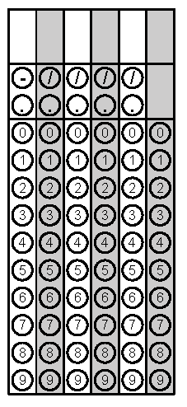
14.)
13.)
12.)
11.)

