Who Were the First Americans?
By Michael D. Lemonick and Andrew Dorfman
Time, March 13, 2006

1

Jim Chatters, a forensic anthropologist, had been called in by the coroner of Benton County, Washington, to consult on some bones found by two college students on the banks of the Columbia River, near the town of Kennewick.
The bones were obviously old, and when the coroner asked for an opinion, Chatters’ off-the-cuff guess was that they probably belonged to a settler from the late 1800s.
2

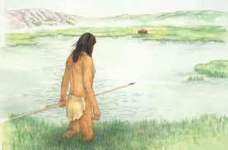
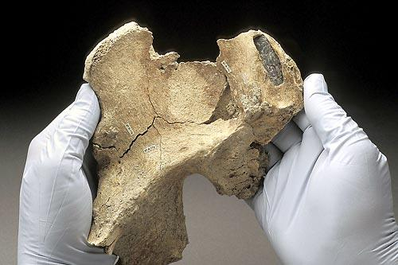
Then a CT scan revealed a stone spear point embedded in the skeleton’s pelvis, so Chatters sent a bit of finger bone off to the University of California at Riverside for radio carbon-dating. When the results came back, it was clear that his estimate was dramatically off the mark. The bones weren’t 100 or even 1,000 years old. They belonged to a man who had walked the banks of the Columbia more than 9,000 years ago.
3

In short, the remains that came to be known as Kennewick Man were almost twice as old as the celebrated Iceman discovered in 1991 in an Alpine glacier, and among the oldest and most complete skeletons ever found in the Americas. Scientists have found only about 50 skeletons of such antiquity, most of them fragmentary. Any new find can thus add crucial insight into the ongoing mystery of who first colonized the New World—the last corner of the globe to be populated by humans. Kennewick Man could cast some much-needed light on the murky questions of when that epochal migration took place, where the first Americans originally came from and how they got here.
4
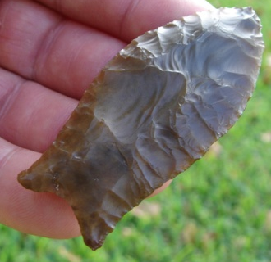
The existence of Kennewick Man leads to the question: Who really discovered America? The conventional answer to that question dates to the early 1930s, when stone projectile points that were nearly identical began to turn up at sites across the American Southwest. They suggested a single cultural tradition that was christened Clovis, after an 11,000-year-old-plus site near Clovis, New Mexcio. And because no older sites were known to exist in the Americas, scientists assumed that the Clovis people were the first to arrive.
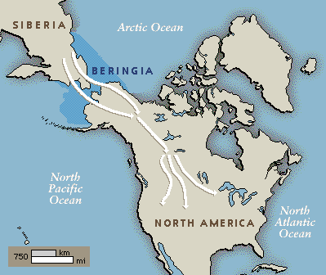
They came, according to the theory, no more than 12,000 years B.P. (before the present), walking across the dry land that connected modern Russia and Alaska at the end of the last ice age, when sea level was hundreds of feet lower than it is today.

However in 1997, a blue-ribbon panel of researchers took a hard look at evidence presented by Tom Dillehay, then at the University of Kentucky, from a site he had been excavating in Monte Verde, Chile.
5
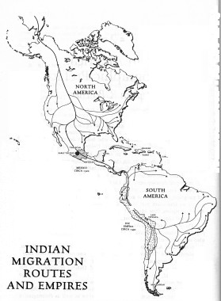
After years of skepticism, the panel finally affirmed his claim that the site proved humans had lived there 12,500 years ago. If people were living in southern Chile 12,500 years ago, they must have crossed over from Asia considerably earlier, and that means they couldn’t have used the ice-free inland corridor; it didn’t yet exist. Instead, many scientists now believe, the earliest Americans traveled down the Pacific coast—possibly even using boats. Even if the earliest Americans traveled down the coast, that doesn’t mean they couldn’t have come through the interior as well.

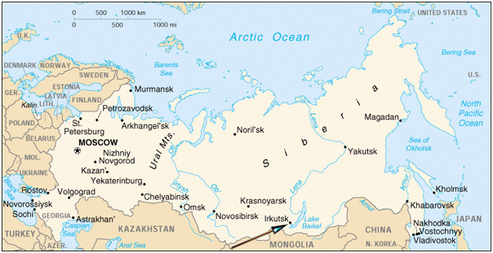

6

Genetics points to an original homeland for the first Americans. “Skeletal remains are very rare, but the genetic evidence suggests they came from the Lake Baikal region” of Russia, says anthropologist Ted Goebel of the University of Nevada at Reno, who has worked extensively in that part of southern Siberia. Goebel speculates that there were two northward migratory pulses, the first between 28,000 and 20,000 years ago and a second, some time after 17,000 years ago. “Either one could have led to the peopling of the Americas,” he says.

Kennewick Man has already added immeasurably to anthropologists’ store of knowledge, and the next round of study is already under way. If scientists treat those bones with respect, the mystery of how and when the New World was populated may finally be laid to rest.

Scientist who studies human remains for evidence of a crime
Doctor who examines dead bodies
Offer advice
Figurative language meaning “without preparation”

Medical test similar to an X-Ray
Stuck in
Hip bone
Method for determining the age of an artifact

A large body of ice
Oldness
Broken into pieces
Very important
Settled
Unclear
Important period of history

An object that is shot or launched
Named or given a name
Accepted as true
Accepted belief

Figurative language meaning “prize winning’ or “expert’
Digging up or uncovering
Doubt
Proved to be true or confirmed
Passageway
Inner or inland

Field of science that studies traits passed down from generation to another
Scientist who studies the development of humans
To a great extent or very much
Thinks or hypothesizes
Without measure or beyond measure

Answer the following questions based on the First Americans article:

1. Kennewick is a __________________ in Benton County, Washington.

2. A 9,000 year old skeleton came to be known as _____________________________.

3. Scientists estimated that the skeleton is from a man who was about _____________________ tall.

4. The discovery of Kennewick Man made some scientists wonder if the ___________ people were really the
First Americans.

5. An archaeological site in Chile called ___________________ also suggests that people came to the
Americas much _____________ than was previously thought.

6. To solve the mystery of the first Americans, scientists hope to find more _______________________.

7. What is the main idea of this article?
a. the first Americans most likely came from the Lake Baikal region of Russia
b. Monte Verde in Chile is the oldest human settlement in the Americas
c. new discoveries are causing scientists to reconsider their theories about the first Americans

8. What can you infer from the fact that scientists have found very few skeletons as old as Kennewick Man?

.

9. What examples can you find in this article that suggest that the first Americans came from Russia?

10. Select the most important discovery;
a. Kennewick Man b. Monte Verde c. Clovis d. Lake Baikal
Explain your choice with at least two reasons.

