Geography of Japan & the Korean Peninsula
Name: ___________________________
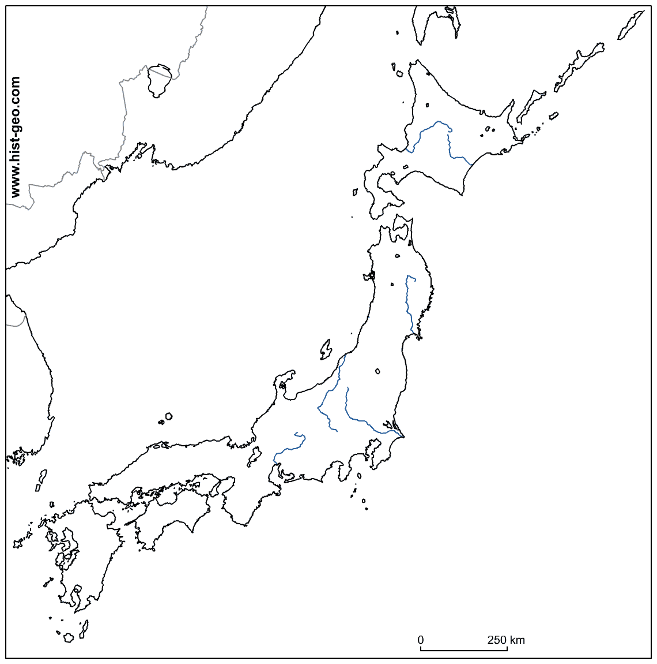
- Label the following on the map. Use pages 225 and 231
Mount Fuji
Hokkaido
Honshu
Shikoku
Kyushu
Korean Peninsula
Sea of Japan
Pacific Ocean
Tokyo
Russia
China

- Complete TALDOGS for this map.
- Extension Activity: Use page225 to color the map to show elevation.

