**http://www.enchantedlearning.com/crafts/memory/timeline/timeline.GIFIslamic Expansion Review Guide**

Name: ______________________________

Core: _______ Date: ___________________

**Part 1: Timeline** *(1 point each)*  
1-5. Complete the timeline below by plotting the dates in the correct order. Then, answer the multiple choice questions below based on the timeline. Be sure to place the events in the correct sequence according to the basic principles of a timeline.

700 CE

800 CE

600 CE

400 CE

500 CE

C

D

B

A

E

1. 613 CE – Muhammad begins to spread his message.
2. 622 CE – Muhammad leave Mecca for Medina. Marks the beginning of Islamic calendar.
3. 632 CE – Muhammad dies. Islam spreads across Southwest Asia and North Africa.
4. 570 CE – Muhammad is born.
5. 610 CE – Angel appears and tells Muhammad to spread the word of God.

How long has Islam been in existence? Show your work. _______________about 1, 400 years___________________

How long did Muhammad live? Show your work. ____________62 years_________________________

**Part 2: Map** *(1 point each)*Draw 5 conclusions about Islamic Expansion based on the map.

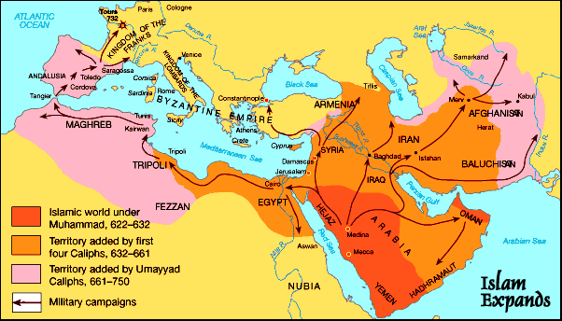

1. Islam spread over many years

2. Islamic leaders used their military to spread the empire

3. Islam had the least followers during Muhammad’s time

4. The Islamic military helped spread Islam over 3 continents

5. The Islamic empire stops at Constantinople, or a Christian area/Empire

**Part 3: Basic Knowledge** *(1 point each)*

Match the word to its meaning.

Arabia_______Region of the world where Islam began___________

Mecca_________A trade city holy to Muslims__________________

Quran or Koran__________The holy book of Islam____________________

Mosque____________A place of worship for Muslims________________________

Muslim_____________A person who practices the religion Islam_______________________

Islam______________A religion that worships one god who they call Allah________________________

C:\Documents and Settings\Administrator\Local Settings\Temporary Internet Files\Content.IE5\YM28U9BX\MC900156537[1].wmf____________________A common symbol for the Islamic faith________________

**Part 4: Split of Islam** *(1 point each)*Read the text (on the separate sheet of paper) and answer the following questions.

What is the main idea of the text? ____There was a major split between Muslims after Mohammad’s death__________

What are the differences between the two main groups?

_______Sunni’s believe their leaders should be elected by other religious leaders, Shiites believe that it should follow a direct lineage _____________

What are the two leaders that are elected by the different groups? ___ Caliph _______ and ____ ayatollahs __

What does the map say about Sunnis and Shiites in the Middle East? __________There are more Sunni Muslims in the world today___________________

**Part 5: Basic Beliefs** (*1 point each)*List each of the 5 pillars of Islam, and explain each one:

1. ___Faith____: ___________The basic statement of Islamic belief that is recited by Muslims_________
2. ____Prayer__: __This is performed 5 times a day, and is considered highly spiritual for Muslims around the world_
3. _____Charity_____: ________ Giving up part of one’s wealth, regarded as a type of self-purification ___________
4. _____Fasting____: This pillar is based on not eating during the hours between sun rise and sun set. This is done during the holiday of Ramadan
5. _____Hajj______: _____ Traveling to Mecca to follow in the footsteps of the Islamic prophet Mohammad___