Civilizations of the Americas
Name: ____________________________________
Date: ______________________ Core: _________
PART A: Locate on a map and explain significance
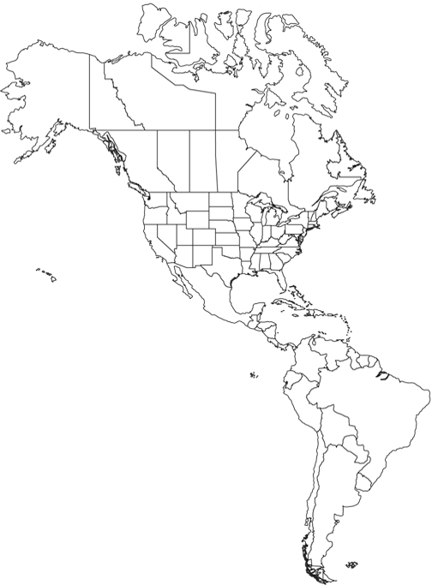
1. Andes Mountains
__________________________________________________
2. Yucatan Peninsula
__________________________________________________
3. Tenochtitlan
__________________________________________________
4. Machu Picchu
__________________________________________________

Part B: Match to description of person
5. Conquistadors
____________________________________________________
6. Hernan Cortes
____________________________________________________
7. Francisco Pizarro
____________________________________________________
8. Quetzalcoatl
____________________________________________________

PART C: Multiple choice of description
9. Polytheistic
__________________________________________________________________________________________
10. Diseases
__________________________________________________________________________________________
11. Mayan Calendar
__________________________________________________________________________________________
12. Pre-Contact or Pre-Colonization
__________________________________________________________________________________________
13. Mesoamerican
__________________________________________________________________________________________

PART D: Answer the essay question below.
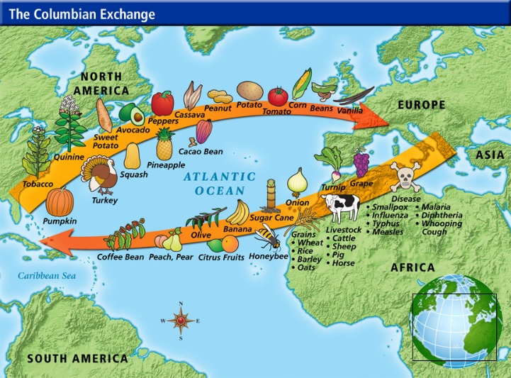
Explain WHAT the Columbian Exchange was and HOW it impacted the eastern and western hemispheres. Use the picture to add details. (This answer could be anywhere from 3 to 5 sentences long.)

