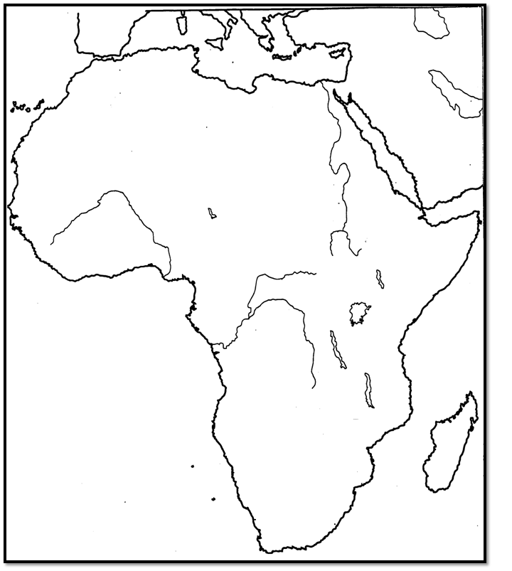
0 500 1000
EUROPE
30°E
10°E
0°
Lake Victoria
0°
20°N
20°s
Byzantine
Empire
Gulf of Aden
N

_______________
1. On the map above, complete the key by writing the name of Ghana, Mali or Songhai on the line next to the
solid, dashed or dotted lines. Use the maps on pages 327 + 335 of the Blue Book – “Eastern World”.

2. What is the distance from the mouth of the Nile River to the mouth of the Congo River? _________miles
3. What is the width of Africa (east to west) at the equator. _________miles

4. Mount Kilimanjaro is (NE, SE, NW, SW) of the Gulf of Aden.

5. Which is the best estimate for the absolute location of the Nile’s mouth? (15°N, 30°E) or (25°N, 30°E)

6. Which is the best estimate for the absolute location of Mt. Kilimanjaro? (3°N, 40°E) or (3°S, 40°E)

7. Which is the best estimate for the absolute location of the Cape of Good Hope? (25°S, 20°E) or (35°S, 20°E)

