Dates of Empire: _______________________
Compass

Scale
Key/Legend
Date Published: _______________________
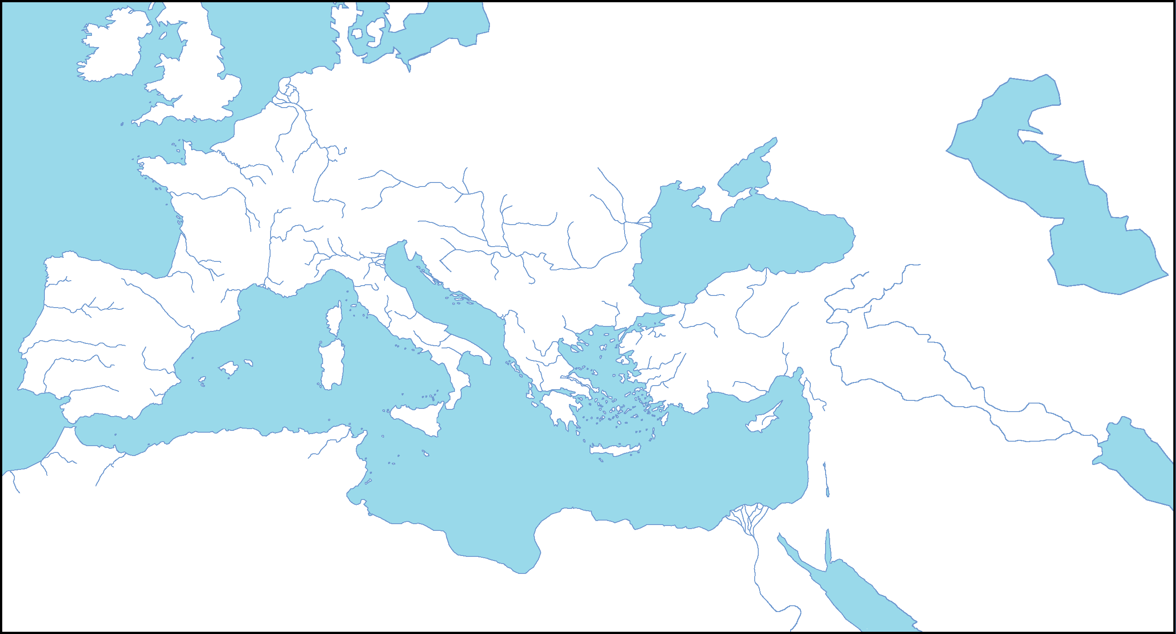
Author: ____________________________
°E
°N

Follow the directions below to complete your map of Ancient Rome.
- Make it a TALDOGS map!
  - Title
  - Author
  - Legend/Key
  - Date
  - Orientation (Compass)
  - Grid
  - Scale
- Label the following territories/locations:
  - Gaul
  - London
  - Rome
  - Alexandria
  - Athens
  - Constantinople
  - Carthage
  - Spain
  - Macedonia
- Label the following bodies of water:
  - Mediterranean Sea
  - Black Sea
  - Danube River
  - Euphrates River
  - Rhine River
- Shade the entire area known as the “Roman Empire” when it was at its height with orange

Follow the directions below to complete your map of Ancient Rome.
- Make it a TALDOGS map!
  - Title
  - Author
  - Legend/Key
  - Date
  - Orientation (Compass)
  - Grid
  - Scale
- Label the following territories/locations:
  - Gaul
  - London
  - Rome
  - Alexandria
  - Athens
  - Constantinople
  - Carthage
  - Spain
  - Macedonia
- Label the following bodies of water:
  - Mediterranean Sea
  - Black Sea
  - Danube River
  - Euphrates River
  - Rhine River
- Shade the entire area known as the “Roman Empire” when it was at its height with orange

