Social Studies 6 Ancient Greece Unit

THE ODYSSEY

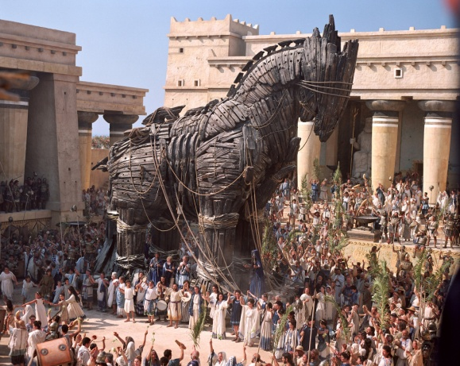
Background In the tenth year of the Trojan War, the Greeks tricked the enemy into bringing a colossal wooden horse within the walls of Troy. The Trojans had no idea that Greek soldiers were hidden inside, under the command of Odysseus. That night they emerged and opened the city gates to the Greek army. Troy was destroyed. Now it was time for Odysseus and the other Greeks to return to their kingdoms across the sea. Here begins the tale of the Odyssey.

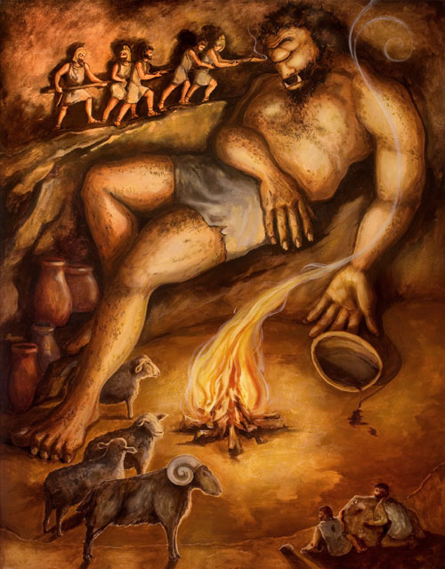
Book 1
My name is Odysseus of Ithaca, and here is my tale since setting out from Troy. We visited the Lotus Eaters, and three of my crew tasted this strange plant. They lost all desire to return home as well as all track of time. They had to be carried off by force. On another island we investigated a cave full of goat pens. The herdsman turned out to be as big as a barn, with a single glaring eye in his forehead. This Cyclops promptly ate two of my men for dinner. We were trapped in the cave by a boulder in the doorway that only the Cyclops could budge, so we couldn't kill him while he slept. Instead we sharpened a pole and used it to gouge out his eye. We escaped his groping by clinging to the undersides of his goats."

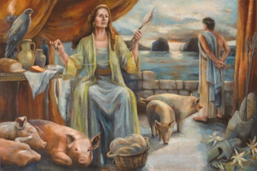
Book 2 Meanwhile, at home on Ithaca, the mansion of Odysseus is infested with suitors for the hand of his wife Penelope. Everyone assumes Odysseus is dead. His son Telemachus calls an assembly to ask for help, and Zeus sends an omen of the suitors' doom. Two eagles swoop down, tearing throats and necks with their talons. Afterwards Telemachus sets sail for the mainland to seek news of his father.
Book 3 "Next we met the Keeper of the Winds, who sent us on our way with a steady breeze. He gave me a leather bag, which my crew mistook for treasure. They opened it and released a hurricane that blew us back to where we'd started. We ended up at the island of the enchantress Circe. My men were entertained by her and then, with a wave of her wand, turned into swine. Hermes gave me an herb that protected me. Circe told me that to get home I must travel to the land of Death."
Book 4 'At the furthest edge of Ocean is the land to which all journey when they die. Here their spirits endure a fleshless existence. They can't even talk unless re-animated with blood.' Accordingly, I did as Circe instructed, bleeding a sacrificed lamb into a pit. Tiresias, the blind prophet who had accompanied us to Troy, was the soul I had to talk to. So I held all the other shades at bay with my sword until he had drunk from the pit. He gave me warnings about my journey home and told me what I must do to ensure a happy death. I met many shades, including Achilles and sadly, my own mother.
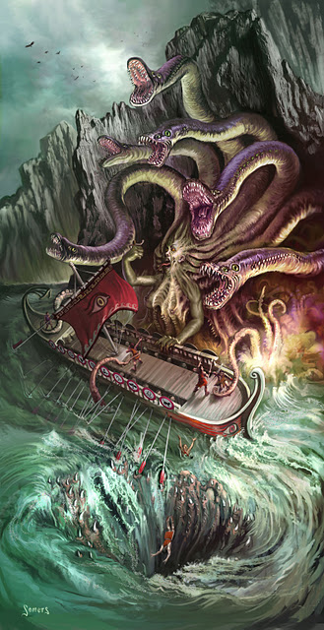
Book 5 "At sea once more we had to pass Charybdis, who swallows
the sea in a whirlpool, then spits it up again. Avoiding this
we skirted the cliff where Scylla exacts her toll. Each of her six slavering maws grabbed a sailor and wolfed him down. Finally we were becalmed on the island of Calypso."
Calypso kept me captive there for years. She was beautiful and promised me immortality, but all I wanted was to get home to see my wife and son.

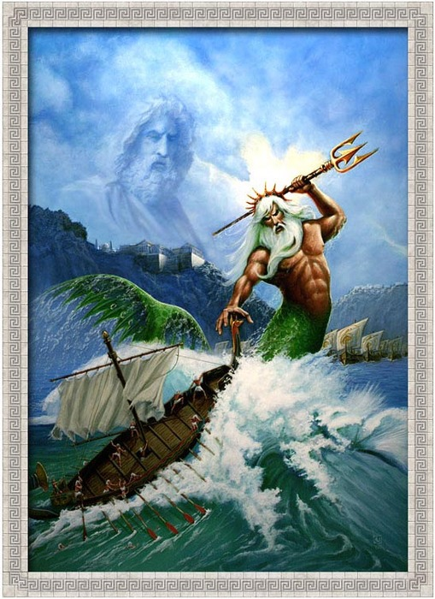

Book 6 Zeus, the King of the Gods, sends his messenger Hermes skimming over the waves on magic sandals to Calypso's island. Though the goddess isn't happy about it, she agrees to let Odysseus go. But the raft on which he sets sail is destroyed by his enemy, the god Poseidon, who lashes the sea into a storm with his trident. Odysseus barely escapes with his life and washes ashore days later, half-drowned. He staggers into an olive thicket and falls asleep. He is found and taken to tell his tale to the king.

Book 7 When Odysseus has finished his tale, the king orders him sped to Ithaca. The sailors put him down on the beach asleep. Athena casts a protective mist about him that keeps him from recognizing his homeland. Finally the goddess reveals herself and dispells the mist. In joy Odysseus kisses the ground. Athena transforms him into an old man as a disguise. Clad in a filthy tunic, he goes off to find his faithful swineherd, Eumaeus, as instructed by the goddess.

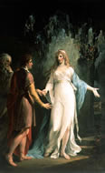
Book 8 Telemachus returns from his journey. Following Athena's instructions, he proceeds to the farm of Eumaeus. There he meets the tattered guest and sends Eumaeus to his mother to announce his safe return. Athena restores Odysseus' normal appearance, and Telemachus takes him for a god. "No god am I," Odysseus assures him, "but your own father, returned after these twenty years." They fall into each other's arms. Later they plot the suitors' doom. Concerned that the odds are fifty-to-one, Telemachus suggests that they might need reinforcements. "Aren't Zeus and Athena reinforcement enough?" asks Odysseus.

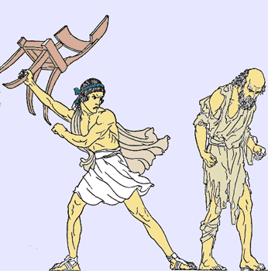
Book 9 Disguised once more as an old beggar, Odysseus returns to his home. At the castle gate, the hero is recognized by an old dog that he had raised as a pup. Having seen his master again, the old hound dies. At Athena's urging Odysseus begs food from the suitors. One man, Antinous, berates him and refuses so much as a crust. He even hurls his footstool at Odysseus, hitting him in the back. This makes even the other suitors nervous, for sometimes the gods masquerade as mortals to test them.

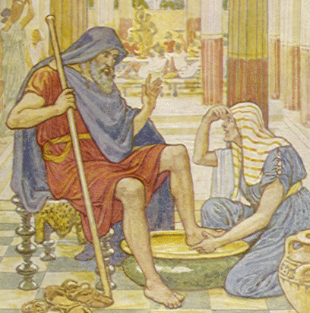
Book 10 Odysseus has a long talk with his queen Penelope but does not reveal his identity. Penelope takes kindly to the stranger and orders her maid Eurycleia to bathe his feet and anoint them with oil. Eurycleia, who was Odysseus' nurse when he was a child, notices a scar above the hero's knee. Odysseus had been gored by a wild boar when hunting as a young man. The maid recognizes her master at once, and her hands go out to hug him. But Odysseus silences her so she does not give away his plot for revenge.

Book 11 The next morning Odysseus asks for a sign, and Zeus sends a clap of thunder out of the clear blue sky. A servant prays that this will be the last day of the suitors' abuse. Odysseus encounters another herdsman. Like the swineherd Eumaeus, this man, who tends the cattle, swears his loyalty to the absent king. A prophet shares a vision with the suitors: "I see the walls of this mansion dripping with your blood." The suitors respond with laughter.

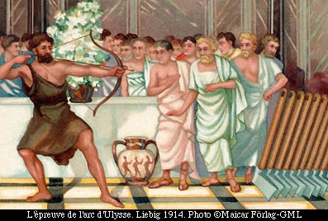
Book 12 Penelope now appears before the suitors in her glittering veil. In her hand is a stout bow left behind by Odysseus when he sailed for Troy. "Whoever strings this bow," she says, "and sends an arrow straight through the sockets of twelve ax heads lined in a row -- that man will I marry." The suitors take turns trying to bend the bow to string it, but all of them lack the strength. Odysseus asks if he might try. The suitors refuse, fearing that they'll be shamed if the beggar succeeds. But Telemachus insists and his anger distracts them into laughter. Odysseus easily strings the bow and sends an arrow through the ax heads. At a sign from his father, Telemachus arms himself and takes up a station by his side.

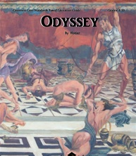
Book 13 Antinous, ringleader of the suitors, is just lifting a drinking cup when Odysseus puts an arrow through his throat. The goatherd sneaks out and comes back with shields and spears for the suitors, but now Athena appears. She sends the suitors' spears and arrows wide, as Odysseus and Telemachus strike with volley after volley of lances. They finish off the work with swords. Those of the housemaids who consorted with the suitors are hung by the neck in the courtyard.

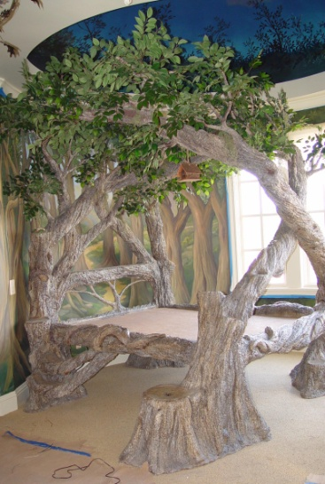
Book 14 The mansion is purged with fire and brimstone. Odysseus tells everyone to dress in their finest and dance, so that passers-by won't suspect what's happened. Even Odysseus could not hold vengeful kinfolk at bay. Penelope still won't accept that it's truly her husband without some secret sign. She tells a servant to make up his bed in the hall. "Who had the craft to move my bed?" storms Odysseus. "I carved the bedpost myself from the living trunk of an olive tree and built the bedroom around it." Penelope rushes into his arms.

Note – in the original Odyssey by Homer, there are 24 books (chapters).
I have combined some and removed others for this summary.
Books 1-5
Match the synonym or definition on the left with the bold, underlined word from the reading.
Synonym/Definition | Word from reading
1. 2.
Books 1-5
Match the synonym or definition on the left with the bold, underlined word from the reading.
Synonym/Definition | Word from reading

Books 6 - 14
Match the synonym or definition on the left with the bold, underlined word from the reading.
Synonym/Definition | Word from reading
Insults
Show
Family
Thick and strong
Pitchfork
Scatters
Cleaned
Disguise

Books 1-5
Match the synonym or definition on the left with the bold, underlined word from the reading.
Synonym/Definition | Word from reading
Drooling
Pigs
Huge
Move
Ghost
Everlasting life
Witch
Mouths
Came out
Sail along the edge
Sign
Men seeking marriage

3. Why was Poseidon angry with Odysseus?

4. Describe two examples of how Odysseus used intelligence to escape the Cyclops.

5. Back on Ithaca, the suitors had moved into the castle of Odysseus. List 2 things they wanted.

6. Why did Aeolus (the keeper of the winds) help Odysseus?

7. In the original book, Circe turns all the men into swine. In the movie she turned them into
many different types of animals. Why do you think the makers of the movie changed the
story?

8. Why did Odysseus travel to the underworld?

9. There is an old saying – “caught between Scylla and Charybdis”. Reread Book 5 and tell what
you think the saying means.

10. Zeus tells Calypso to send Odysseus home, but Poseidon causes a storm that almost kills
Odysseus. What does this tell you about the religious beliefs of the Greeks?

11. When Odysseus finally returns to Ithaca, Athena disguises him to look like an old beggar.
Why do you think she did this? What might have happened differently if Odysseus had
not been disguised?

12. In Book 8, what does Odysseus mean by “Aren’t Zeus and Athena reinforcement enough?”

13. Odysseus could have forced the suitors to leave, rather than kill the m all. Why do you think
Homer (the author) chose to have his hero kill so many men? Does this suggest anything to
you about the values of the Greeks?

