Pre-Colonial Africa

Name:__________________ Core:____

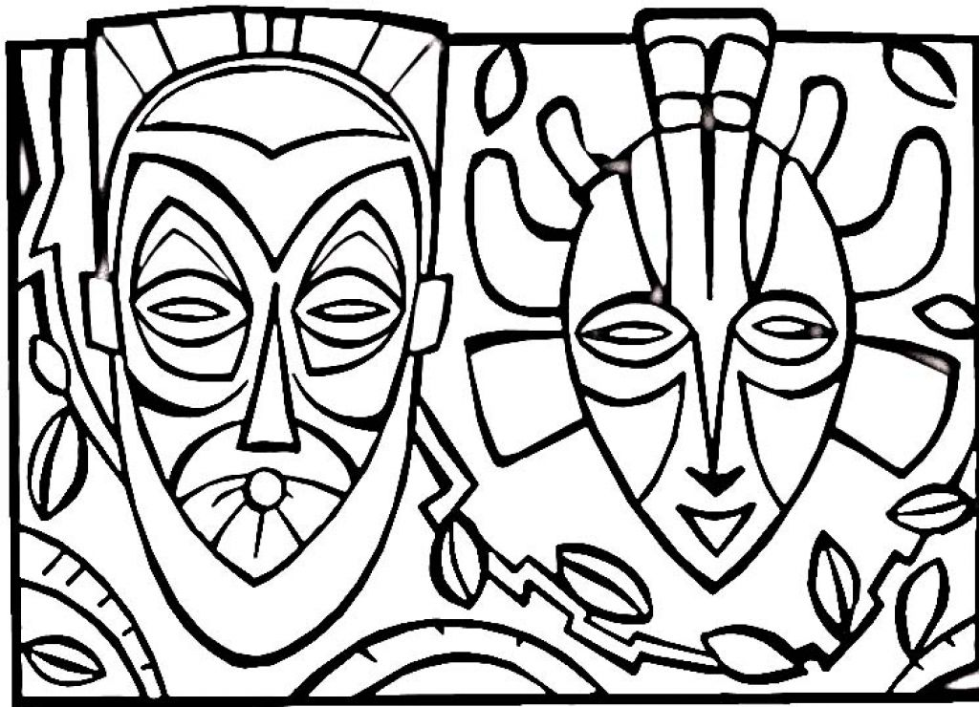

*Color in your free time!*

Welcome to Africa! Following this sheet are two blank maps of Africa.

One of the maps is labeled “Geographic Feature Map.” Your task for this map is to locate and label specific geographic features found on and around Africa.

The other map is labelled “Kingdom Map.” For this map, your task is to locate and label/color specific African kingdoms, empire or cities.

For the Geographic Feature Map, you are required to locate and label the following physical features:
- Mediterranean Sea
- Red Sea
- Atlantic Ocean
- Indian Ocean
- Cape of Good Hope
- Nile River
- Niger River
- Congo River
- Atlas Mountains
- Mt. Kilimanjaro
Shade your map with colored pencils in a way that makes the distinction between the following areas clear:
- Sahara Desert
- Sahel Desert
- Savannah grasslands
- The Great Rift Valley

For the Kingdom Map, you are required to locate and label the following kingdoms, empires, or cities:
- Nubia
- Great Zimbabwe
- Aksum
- Ghana
- Mali
- Songhai
- Timbuktu
REMEMBER THAT YOUR MAPS MUST BE TALDOGS MAPS!!!

Geographic Feature Map

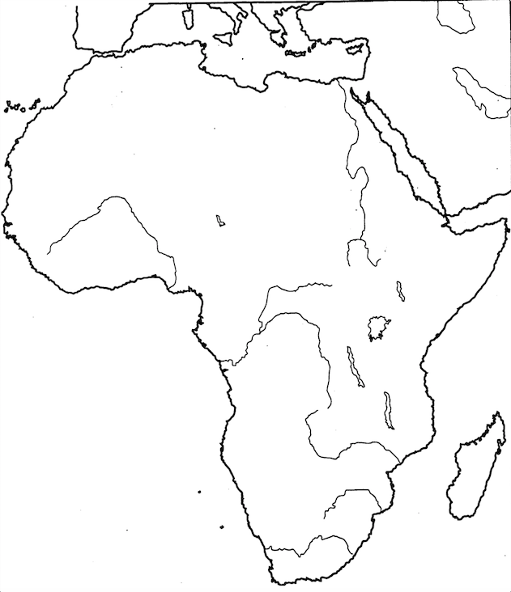

Kingdom Map

The Kingdom of Ghana
Source 1:

The following description of the Kingdom of Ghana was written by Al-Bakri, a member of a prominent Spanish Arab family who lived during the 11th century.

The city of Ghana consists of two towns situated on a plain. One of these towns, which is inhabited by Muslims, is large and possesses twelve mosques, in which they assemble for the Friday prayer. There are salaried imams and muezzins, as well as jurists and scholars. In the environs are wells with sweet water, from which they drink and with which they grow vegetables. The king’s town is six miles distant from this one….
Between these two towns are continuous habitations. …In the king’s town, and not far from his court of justice, is a mosque where the Muslims who arrive at his court pray. Around the king’s town are domed buildings and groves and thickets where the sorcerers of these people, men in charge of the religious cult, live. In them too are their idols and the tombs of their kings. These woods are guarded and none may enter them and know what is there…. The king’s interpreters, the official in charge of his treasury and the majority of his ministers are Muslims. Among the people who follow the king’s religion only he and his heir apparent (who is the son of his sister) may wear sewn clothes. All other people wear robes of cotton, silk, or brocade, according to their means. All of them shave their beards, and women shave their heads. The king adorns himself like a woman (wearing necklaces) round his neck and (bracelets) on his forearms, and he puts on a high cap decorated with gold and wrapped in a turban of fine cotton. He sits in audience or to hear grievances against officials in a domed pavilion around which stand ten horses covered with gold-embroidered materials. Behind the king stand ten pages holding shields and swords decorated with gold, and on his right are the sons of the (vassel) kings of his country wearing splendid garments and their hair plaited with gold. The governor of the city sits on the ground before the king and around him are ministers seated likewise. At the door of the pavilion are dogs of excellent pedigree who hardly ever leave the place where the king is, guarding him. Round their necks they wear collars of gold and silver studded with a number of balls of the same metals. The audience is announced by the beating of a drum which they call duba made from a long hollow log. When the people who profess the same religion as the king approach him they fall on their knees and sprinkle dust on their head, for this is their way of greeting him. As for the Muslims, they greet him only by clapping their hands….
Their religion is paganism and the worship of idols….
On every donkey-load of salt when it is brought into the country their king levies one golden dinar and two dinars when it is sent out. … The best gold is found in his land comes from the town of Ghiyaru, which is eighteen days’ traveling distance from the king’s town over a country inhabited by tribes of the Sudan whose dwellings are continuous…
The king of Ghana when he calls up his army, can put 200,000 men into the field, more than 40,000 of them archers.

According to the description, draw your interpretation of the King.

Source 2: http://www.bbc.co.uk/worldservice/africa/features/storyofafrica/4chapter1.shtml

Source 3: http://africa.mrdonn.org/griots.html

The Kingdom of Mali

The Empire of Mali was located in Western Africa. It grew up along the Niger River and eventually spread across 1,200 miles from the city of Gao to the Atlantic Ocean. Its northern border was just south of the Sahara Desert.

The Empire of Mali was established around 1235 CE. It began to lose power in the 1400s and fully collapsed in 1600 CE. It was formed when a ruler named Sundiata Keita united the tribes of the Malinke peoples. He then led them to overthrow the rule of the Soso. Over time, the Mali Empire became stronger and took over surrounding kingdoms including the Empire of Ghana.

The government of the Mali Empire was led by the emperor who was called the Mansa. The empire was then divided up into provinces that were each led by a governor called a ferba. The religion of Islam played an important part in the government and many of the government administrators were Muslim scribes.

Although there were many small tribes and cultural groups within the Mali Empire, most of these groups were considered part of the Mande peoples. The Mande peoples spoke similar languages and had similar cultures. People were divided into castes. One of the most respected castes were the farmers. Farmers were highly regarded because they provided food. Just below the farmers were the artisans. Other groups included fishermen, scribes, civil servants, soldiers, and slaves. The religion of Islam was an important part of the Mali Empire. However, even though the kings, or Mansas, had converted to Islam, they did not force their subjects to convert. Many people practiced a version of Islam that combined Islamic beliefs with the local traditions.

Perhaps the most famous of the Mali Emperors was Mansa Musa. Mansa Musa became famous because of his lavish trip to Mecca in Saudi Arabia. Mecca is the holy city of the Muslims and Mansa Musa decided to make a pilgrimage to Mecca in 1324. It is said that Mansa Musa was extremely rich and that he brought as many as 60,000 people along with him on his pilgrimage. He also brought camels loaded with gold. Mansa Musa must have made quite the impression during his trip with his large entourage and massive display of wealth. During his travels, Mansa Musa gave away and spent a significant amount of gold, but he also brought back a lot of new ideas to Mali. This included a number of scholars such as architects, poets, and teachers who helped to improve his empire.

Not long after the rule of Mansa Musa ended, the Mali Empire began to grow weak. In the 1400s, the empire began to lose control along the edges of its borders. Then, in the 1500s, the Songhai Empire rose to power. The Mali Empire came to an end in 1610 with the death of the last Mansa, Mahmud IV.
This text is Copyright © Ducksters. Do not use without permission.

Identify 3 things that you learned from this text:

1:
2:

3:

Blog Post: Mansa Musa of Mali Named World’s Richest Man of All Time; Gates and Buffet Also Make List

You've probably never heard of him, but Mansa Musa is the richest person ever.

The 14th century emperor from West Africa was worth a staggering $400 billion, after adjusting for inflation, as calculated by Celebrity Net Worth. To put that number into perspective – if that's even possible – Net Worth's calculations mean Musa's fortune far outstrips that of the current world's richest man Carlos Slim Helú and family. . . .

According to the Encyclopedia Britannica, when Musa died sometime in the 1330s, he left behind an empire filled with palaces and mosques, some of which still stand today. But the emperor really turned historic heads for the over-the-top extravagances of his 1324 pilgrimage to Mecca.

The trip, which he embarked upon during the 17th year of the monarch's glittering reign, was hosted by the leaders of both Mecca and Cairo and apparently was so brilliant, it "almost put Africa’s sun to shame."

Musa’s wealth was a result of his country’s vast natural resources. The West African nation was responsible for more than half of the world’s salt and gold supply, according to Net Worth. Of course, the entry also notes that the fortune was also fleeting. Just two generations later, his net worth was gone – wasted by invaders and infighting.
Source: The Huffington Post, October 17, 2012.

Blog Post Questions

- Who created this blog post? When was it created? Why do you think it was written?

- What is the main point of the blog post?Identify two claims it makes.

- What evidence does it use to support its claims?

- Do you think the information in this blog post is trustworthy? Why or why not?

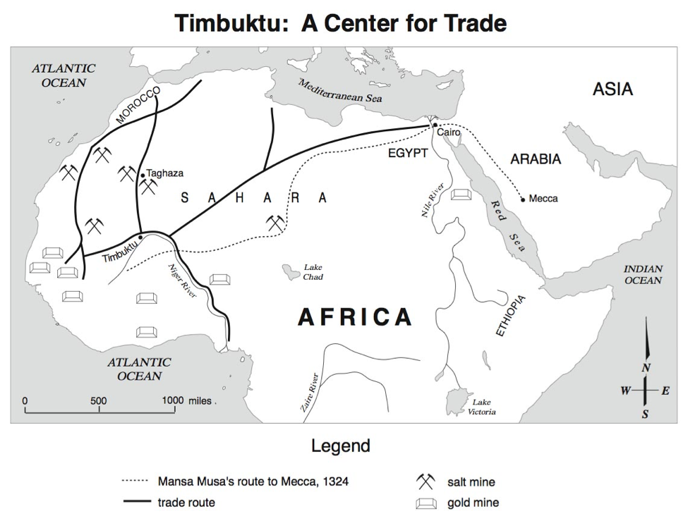

Use the map above to answer the following questions.
1. About how far did Mansa Musa travel on his Hajj? __________________________________
2. What was traveling along the trade routes in North Africa? _____________&______________
3. What body of water would have been most useful to the traders of Timbuktu? _____________
Why?____________________________________________________________________________________________________________________________________________________________________________________________________________________________________
4. Which Theme of Geography does this map best represent? ____________________________
5. Which direction does the Niger River flow? ________________________________________
How do you know? __________________________________________________________________________________________________________________________________________________________________________________________________________________________________________

Salt and Gold Trade Reflection
Think about your experience with the Salt and Gold exchange, then answer the following reflections.
1. Why was salt important?

2. Why might gold be important?

3. What is a tax, tariff or tribute?

4. How did the King of Ghana use it to make his kingdom wealthy?

5. What role did you take on in the simulation?

6. Do you feel you were successful in your trades? Why or why not?

7. What problems did you encounter when you could not talk with the person with whom you wished to trade?

8. Why were traders willing to pay this tax to Ghana?

