Nebraska looking at ways to grow urban agriculture

By GRANT SCHULTE, Associated Press Updated 7:30 am, Saturday, May 31, 2014
1 of 7
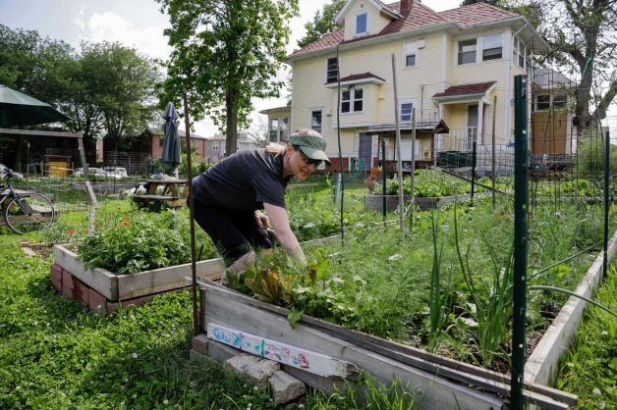
In this photo from May 29, 2014, urban gardener Jo Bartikoski picks dill from her garden patch at the Dundee community garden in Omaha. Nebraska State Sen. Burke Harr of Omaha wants to expand the use of community gardens in urban areas. He is launching a study this summer to try to make it easier to start community gardens, possibly by allowing them to grow on public land. Photo: Nati Harnik, AP

LINCOLN, Neb. (AP) — Five years have passed since a group of neighbors started planting rosemary, tomatoes and peas on an empty lot in the middle of Omaha. Now, the Dundee Community Garden helps feed low-income seniors in a housing complex across the street. A regular crowd gathers every Saturday to tend their crops. The garden is so popular that 15 aspiring growers have signed onto a waiting list for the next available plot.

"We're drawn by the ability to grow our own fresh produce," said Jo Bartikoski, one of the founding members. "Everybody has their own plot, and they can grow whatever they want."
Nebraska is known for its corn, soybeans and beef — and now, in a state where farming is king, one state senator is looking at bring more agriculture into cities. Sen. Burke Harr of Omaha has introduced a legislative study to consider ways the state can help develop new community gardens. Harr said the gardens could address some of the need in so-called "food deserts" in Omaha, Lincoln and other areas that lack easy access to quality food. They also could teach children in cities about agriculture.

"The idea is to bring the community together," Harr said. "It teaches kids responsibility, and gives them a payoff for their work. My kids won't eat vegetables, but they love watching the vegetables grow — and they'll eat the ones that we grow in our garden."
The study will focus on new places to plant, such as public-school grounds. Senators may also look at a 2013 California law passed in 2013, which lets cities and counties lower the assessed value — and property taxes — on plots of three acres of less, as long as the owner agrees to dedicate the land to food-growing for at least five years.
Another unexplored idea is to use public right of ways purchased by the Nebraska Department of Roads. The department acquires land long before construction work begins, and can leave it sitting empty for years. During that interim, Harr said, the state could lease the land to a community gardening group for as little as $1 per year. Or, he said, the state could create a startup cash fund to help establish small urban farms in city parks.

Interest in community gardens has exploded in Lincoln, particularly among immigrants and refugees who want to continue farming as they did in their native lands. Last year, community gardens organized by a local nonprofit produced 28,000 pounds of food.
Community CROPS, which helped create the gardens, now has 250 plots being cultivated throughout the city — a 25 percent increase over last year. The group received about 350 applications for the current season, but didn't have enough gardening space or resources.
"The demand is way beyond what we can satisfy," said Ben McShane-Jewell, the group's community garden program manager. McShane-Jewell said the group tries to give priority to people who need food the most.

Community gardens have gained popularity with churches, schools and even private companies, said Sarah Browning, an educator who teaches horticulture for the University of Nebraska-Lincoln's Lancaster County extension. "I think there's a social aspect for people who garden, because they get to meet other people who share that interest," Browning said. "There's certainly a physical benefit, from the activity that comes with gardening. And of course there's the financial benefit of people being able to grow their own produce."

At the same time, she said, starting a garden sometimes proves more difficult than people realize. She pointed to a community garden in Fremont, on a plot of land that couldn't be developed because of a nearby airport. Using the land required the city's approval, she said, and a lack of nearby water required the group to raise money to install water lines.
Neighbors may also view the gardens as an eyesore, especially when they're not well-maintained. New gardeners occasionally start with a plot that's too big to manage alone. And with school gardens, Browning said, it's important to have enough people involved to maintain the plot year-round.
"If kids aren't there in the summer, that's when most of the crops are growing," Browning said. "They need a lot of attention and a lot of weeding. Who's going to do that? It's one consideration that trips people up."

