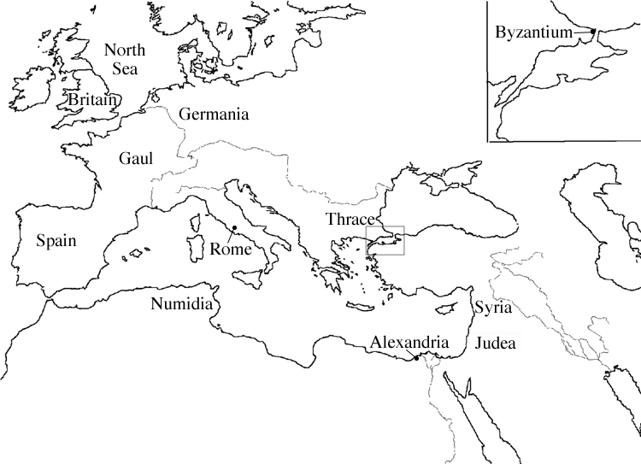
Roman City Directions
You have been hired as an architect to design the city layout for the newest city conquered by the Romans. Please follow the checklist below to make sure that you have completed the BEST work you can do!
Follow these steps:
- You must pick a section of the Roman Empire to put your new city.
Section:______________________________________

- Use an atlas or textbook to find out about the geography of the place you have picked. Does your area have any of the following:
- A river
- Mountains or mountain range
- Coastal region

Each Roman City MUST HAVE:
- Title (name the city; be sure to provide the Latin and English translation)
- Author (that’s you!)
- Legend
- Date (published and date of your ancient city)
- Orientation (compass)
- Grid (label the x- and y-axis using letters and numbers)
- Scale (measurements can be in feet, yards, or meters)
- Color
- Aqueducts
- Thermae
- Insula
- Forum
- Amphitheater
- Farmland
- Walls and gates
- Roads

Each Roman City COULD HAVE:
- River
- Mountains
- Coast (beach)
- Watchtowers
- Lake
- Reservoir
- School
- Park
- Military training space
- Fountain
- Temples (and statues)
- Market
- Speed bumps
- Basilica
- Government buildings
- Colonnade
- Water fountains
- Public restrooms
- Jails
- Blacksmith shop
- Gardens
- Wealthy homes
- Library

When revising and editing, pay special attention to your CUPS:

- Capitalization
- Usage
- Punctuation
- Spelling

