Sharia: Islamic Law
All aspects of a Muslim's life are governed by Sharia. Sharia law comes from a combination of sources including the Qur'an (the Muslim holy book), the Hadith (sayings and conduct of the prophet Muhammad) and fatwas (the rulings of Islamic scholars).

Sharia, or Islamic law, influences the legal code and politics in most Muslim countries. A movement to allow Sharia to govern personal status law, a set of regulations that pertain to marriage, divorce, inheritance, and custody, is even expanding into the West.

What is Sharia?
Also meaning "path" in Arabic, sharia guides all aspects of Muslim life, including daily routines, familial and religious obligations, and financial dealings. It is derived primarily from the Quran and the Sunna--the sayings, practices, and teachings of the Prophet Mohammed.
Sharia developed several hundred years after the Prophet Mohammed's death in 632 CE as the Islamic empire expanded to the edge of North Africa in the West and to China in the East. Since the Prophet Mohammed was considered the most holy of all believers, his life and ways became a model for all other Muslims and were collected by scholars into what is known as the hadith. As each city tried to reconcile local customs and Islam, hadith literature grew and developed into different Islamic teachings. Named after the scholars that inspired them, they differ in the weight each applies to the sources from which sharia is derived, the Quran, hadith, Islamic scholars, and consensus of the community. Some scholars believe sharia should be loosely followed, others believe that if you break the sharia law, you should be killed or stoned to death.

Whether democracy and Islam can coexist is a topic of heated debate. Some conservative Muslims argue democracy is a purely Western concept imposed on Muslim countries while more liberal Muslims argue the freedoms of a democracy is supported by sharia law.

http://www.cfr.org/religion/islam-governing-under-sharia/p8034

Questions to discuss:
- How would you define the Sharia?
- What parts of a Muslim’s life does the Sharia determine or guide?
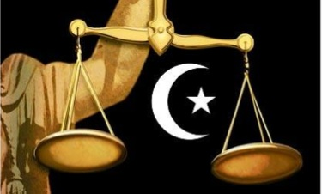
- Why would there be different interpretations of the Sharia?
- Why wouldn’t the Sharia be able to fit into a democracy, or can it? What does the Sharia base its laws from? What is a basic freedom of living in a democracy?

