Ancient Greece Review Guide
Name: _______________________
Core: _______ Date: ___________
Part 1: Reading a Map
Using the map on page 310 in your World Studies textbook answer the following questions.
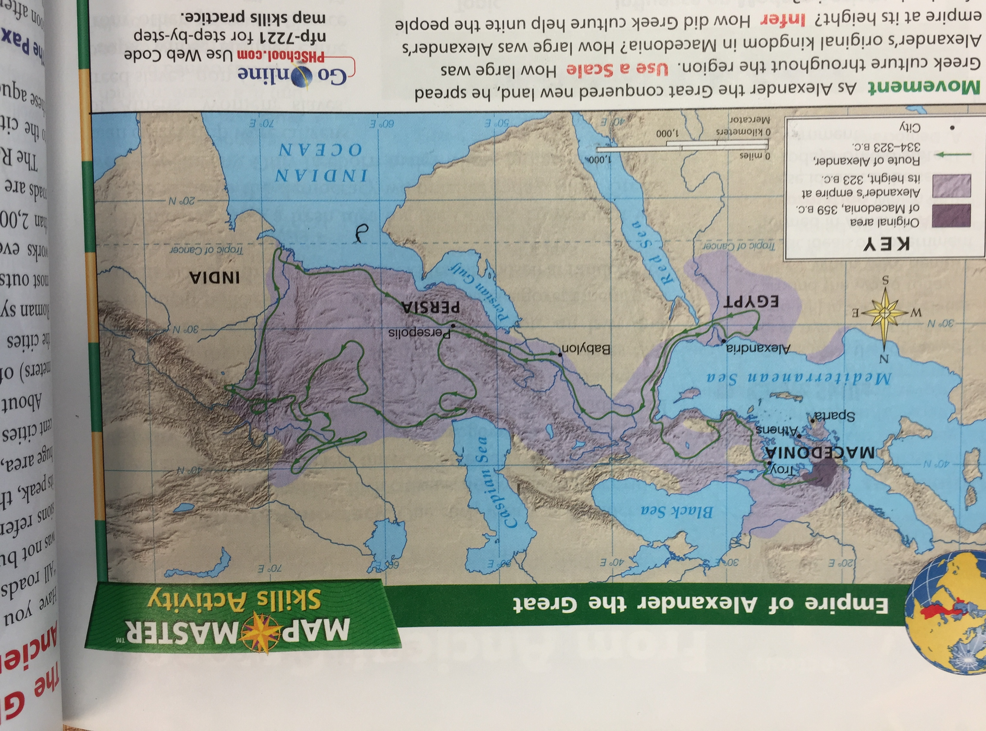
- How large was Alexander’s original kingdom in Macedonia? ~200 miles long ~200 miles wide

- How large was Alexander’s empire at its height? ~3800 miles east-west ~1800 miles north-south

- How did Greek culture help unite the people of such a large area? The Greek culture united all the people of the empire because the people shared a common language, religion, government, and traded with each other.

- What is the name of the city where Alexander’s route ended? Babylon

- Name the three continents that Alexander’s empire included at its height:

  - Europe
  - Africa
  - Asia

Part 2: Vocabulary
City-state – the way the country was divided; Athens and Sparta are examples of this
Gymnasia – people trained, learned, and socialized here
Alexander the Great – a military genius that expanded Ancient Greece
Agora – a popular meeting place where people could shop and talk
Myths – they taught lessons of the gods and goddesses and explained elements of nature
Acropolis – city on the hill
Parthenon – example of Greek architecture
Hippocratic Oath – what doctors say before practicing medicine; named after Hippocrates, the father of medicine
Columns – most obvious trait of Greek architecture on the fronts of many buildings today
Knowledge – something most Greeks strived to acquire or gain
Olympics – athletes competed in these
Mt. Olympus – where the gods resided or lived
Socrates – a famous philosopher
Pericles – a general in Athens responsible for rebuilding the acropolis after it was destroyed during the Persian wars

Part 3: Greek Religion--Mythology
Be familiar with the gods and goddess from your notes! Make sure you know what they represent!
Athena – goddess of wisdom and knowledge
Apollo – god of sun, light, healing and medicine; had a twin sister
Zeus – king of the gods; his symbol was the thunderbolt
Hades – brother of Zeus; god of the Underworld
Medusa – monstrous woman who could turn people to stone
Poseidon – brother of Zeus; god of the sea, earthquakes, and horses
Part 4: Analogies
Be able to complete analogies about Greece and tell why you chose your answer.
- Athens: education :: Sparta: ____________________
- agora: Ancient Greece :: ___________________ : modern-day United States

Part 5: Reading a Table
- Annotate the table below.
- Draw conclusions about the legacy of the Greeks.
- Identify topics (using details) where the Greeks have influenced modern day America. Be specific.



