The Emperor Justinian
At the height of the Byzantine Empire, a talented and hard working emperor by the name of Justinian came to the throne at the age of 44. Prior to his rise to the throne, Justinian spent countless hours studying everything from music, to architecture, to politics. These studies paid off, and would help Justinian become one of the greatest emperors to sit on the Byzantine throne.
Justinian was a wise ruler who wanted his people to be successful and comfortable. He instituted a number of reforms to help make the lives of his subjects better. One of these important reforms had to do with the rights of women.
Justinian granted women the right to buy land and own property. This insured that widows would have the ability to care for their families after the death of their husbands.
The Corpus of Civil Law
For centuries, the Senate in Rome had been passing laws and ordinances governing the actions of Roman citizens. Roman emperors had also established thousands of decrees and laws. Up until now, these laws were recorded in a variety of scrolls, books and tablets, which were spread throughout the Roman Empire. This made it very difficult for Romans to understand their laws and rights.
The Byzantines inherited their legal system from the Romans. The Byzantine emperor Justinian hired a commission to review all the laws that had accumulated over the centuries and to simplify them. This commission categorized the laws into classes based on the issues that they dealt with. They combined many similar laws, made complex laws more simple, while getting rid of many outdated laws.
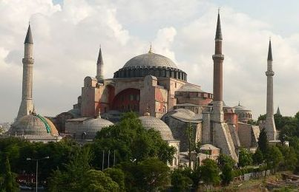
This new system of laws was all recorded in a single book known as the Corpus of Civil Law, or Justinian Code. The Corpus of Civil Law would become the basis for the laws of many western civilizations.
1 Hagia Sophia funded by Justinian

The Empress Theodora
Theodora was the wife of Justinian I who was crowned Emperor of the Byzantine Empire in 527 AD. As his wife, she ruled by his side, as his partner, and her intelligence helped to advance the Empire.
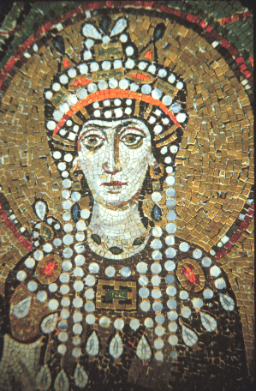
At the age of 16, she traveled to northern Africa as the companion of an official. She stayed there for 4 years before returning to Constantinople. Upon returning to Constantinople in 522, she settled down as a wool spinner in a house near the palace of the Emperor. It was while in this humble lifestyle, at the age of 20, that she drew the attention of Justinian, then a government official.
Theodora was not only beautiful, but intelligent, witty and amusing, which is perhaps why she won Justinian's love so much that he appealed against an old Roman law that forbade officials from marrying actresses in order to marry her. Justinian and Theodora were married in 525. In 527, Justin, the emperor of Byzantium, and Justinian's father died. The couple assumed control of the Empire and were crowned Emperor and Empress on 4th April of that same year. They ruled unofficially as joint monarchs with Justinian allowing Theodora to share his throne and take active part in decision making.
Perhaps the most significant event during Empress Theodora's rule was the Nika revolt in which she proved herself a worthy and able leader. During this event, two rival political groups started a riot at the Hippodrome. They set many public buildings on fire and proclaimed a new emperor. Justinian and his officials, unable to control the crowd prepared to flee, but Theodora spoke up and gave a moving speech about the greater significance of the life of someone who died as a ruler, over that of someone who lived but was nothing. Her determined speech convinced Justinian and his officials and they attacked the Hippodrome, killing over 30,000 rebels and emerging victorious. Historians agree that it was Theodora's courage and determination that saved Justinian's empire.
Throughout the rest of her life, Theodora and Justinian transformed the city of Constantinople, building it into a city that for many centuries was known as one of the most wonderful cities in the world. They built aqueducts, bridges, and more than 25 churches, the most significant of these being the Hagia Sophia - 'Church of Holy Wisdom'. To women, Theodora may well be considered a noble pioneer of the women's liberation movement. She passed rights that granted women more rights in divorce cases and established laws allowing women to own and inherit property.
Empress Theodora died on 28th June, 548. Her body was buried in the Church of the Holy Apostle, one of the splendid churches that she and Justinian had built in Constantinople. Beautiful mosaics in Empress Theodora's remembrance exist to this day at the Church of San Vitale at Ravenna in Northern Italy. Even after her death, her spirit lived on, and in this way she was able to have influence on the Empire. Because of Theodora the status of women in the Byzantine Empire was elevated high above that of the women in the Middle East and Europe.

