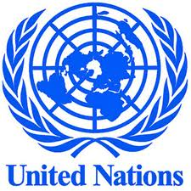
The Grant Project
Day 1 – Today you will research these nine topics. You’ll read a bit about each topic, write down key words and phrases, and write a one-sentence summary of each topic.
- Rising Out of Poverty
- Reversing the Spread of HIV/AIDS
- Preventing Communicable and Non-communicable Diseases
- Improving Nutrition for All
- Improving Access to Clean Water and Basic Sanitation
- Reducing the Global Gender Gap
- Promoting Environmental Sustainability
- Ensuring Access to Quality Education
- Addressing Global Food Security
Today’s goal is for you to learn a little about all nine topics. Soon you will rank your TOP THREE CHOICES and will then be assigned a topic based on your personal preferences.
----------------------------------------------------------------------------------------------------------------------------------------
As an individual you will…
- Research your topic using the Peace Corps Webquest
- Complete a graphic organizer
- Answer essential questions

As part of a small group you will create and present a Prezi in which you…
- Introduce the topic.
- Provide evidence of a problem.
- Offer a solution.
- Explain the benefits of the solution.
- End with a call to action. Urge your audience to act now to make a difference. Remind the committee why your team should win the $1,000,000 grant.

This is called “The Grant Project” because you will present your Prezi to a committee of United Nations committee members. Your goal is to persuade them to give YOUR GROUP the $1,000,000 grant because your group is focused on a very important topic AND you have an effective, realistic solution to the problem.

