Trading Gold for Salt
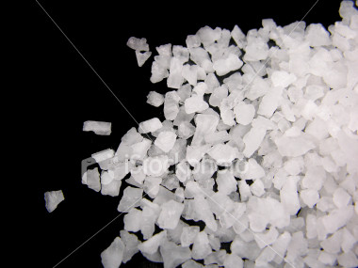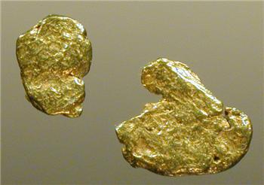
- What is trade? Give an example from your own life when you traded on object or service for another.

2) Locate Ghana on your Africa Map. Where is Ghana located? Use directional words (north, south, east and west) as well as geographic features (river, desert, savanna) to explain the relative location of Ghana.

3) Why was salt important?

4) Why might gold be important?

5) What is a tax, tariff or tribute? How did the King of Ghana use it to make his kingdom wealthy?

6) What natural resources were located in Ghana?

7) How did the geography of Ghana make it rich?

8) What is more important to you, having a lot of gold or a lot of salt? Explain your answer.

Source:http://mslustigss6.wikispaces.com/file/view/Gold+Salt+Trade+worksheet.pdf/311936596/Gold%20Salt%20Trade%20worksheet.pdf

