Vikings
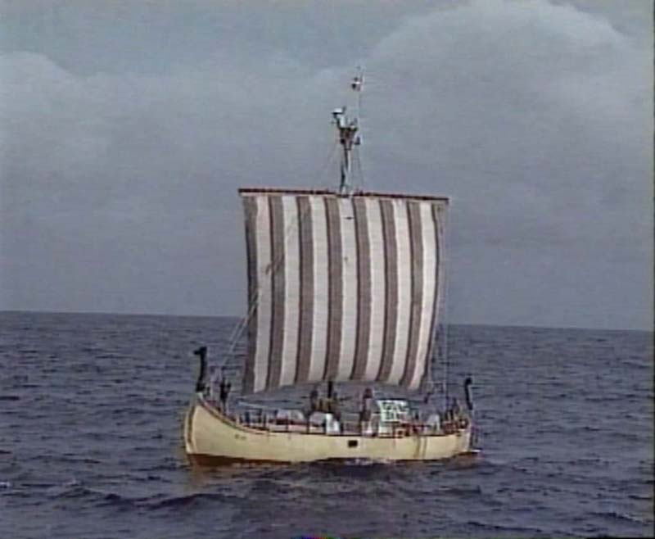
A Viking ship (reconstructed)
The Vikings were Indo-European people from Scandinavia (modern Denmark, Norway and Sweden), who began around the 400s AD to make frequent raids by boat into Europe, even going into the Mediterranean Sea and raiding Sicily and southern Italy. The Vikings began attacking the Atlantic coast of southern France around 400 AD, and also the eastern coast of England.
In 860 AD, another branch of Vikings migrated south into Russia to trade with Constantinople. In Russia, the Vikings gradually mixed with the Slavs who were living there and founded the country of Russia. Together, the Slavs and the Vikings took their boats down the Dnieper river to the Black Sea, where they traded with people further east along the Silk Road like the Samanids. The Vikings sold furs and wool to the Samanids, and the Samanids sold the Vikings silk from China.
The Vikings and the Slavs also raided the Roman territory around Constantinople, though they could not take the city itself. Soon the Byzantine Empire was hiring Vikings as soldiers. Many Viking men fought for the Byzantines at the Battle of Manzikert between the Byzantines and the Seljuks in 1071 AD. By about 1100, most Vikings had converted to Christianity.
By 1000 AD, some of the Vikings settled in northern France, where they were called the Normans, or Northmen, and the area where they settled is still called Normandy. Here they also converted to Christianity. At around the same time, some Vikings sailed west as Iceland, Greenland, and even as far as Nova Scotia, in modern Canada. Some Viking men married Native American women there. The Vikings settled in Iceland and Greenland, but only stayed in Canada for a short time, because the Inuit people there were too strong for them, and because a global cooling period beginning about 1300 AD made the oceans too icy for their ships.

