Ancient Africa Review Guide

Name: __________________________

Date: ____________ Core: __________

Date: _______________ Core: _______

**PART I. Identification**

**Complete the following terms. (Use your notes from the PowerPoint and text)**

1. Savanna Grassland scattered with scrubs and isolated trees.
2. Mansa Musa Mostly known for his extravagant hajj to Mecca and being the richest man in the world.
3. Aksum The kingdom that lost their power when the Arabs took over trade routes.
4. ­­­Griots Are storytellers in western Africa who shared oral stories.
5. Bantu The language of the people of Zulu.
6. Sahel Is the semi-arid climate, it stretches across the south0central latitudes of Northern Africa between the Atlantic Ocean and the Red Sea.
7. Salt & Gold Trade Brought wealth to many empires.
8. Sundiata Founder of Mali and also known as the Lion King.
9. Islam Was introduced to Ghana in the 9th Century and the spread of the religion introduced a larger world of religion and trade.
10. Folktales Stories that are passed down through generations and are told orally.

**PART II. Mapping See attached picture on weebly for answers.**

**Identify the following features on the map of Africa**.

Nile River

Niger River

Congo River

Kingdom of Mali

Aksum

Nubian Kingdom

Sahara Desert

Timbuktu

**Legend:**

= River = Kingdom = Other

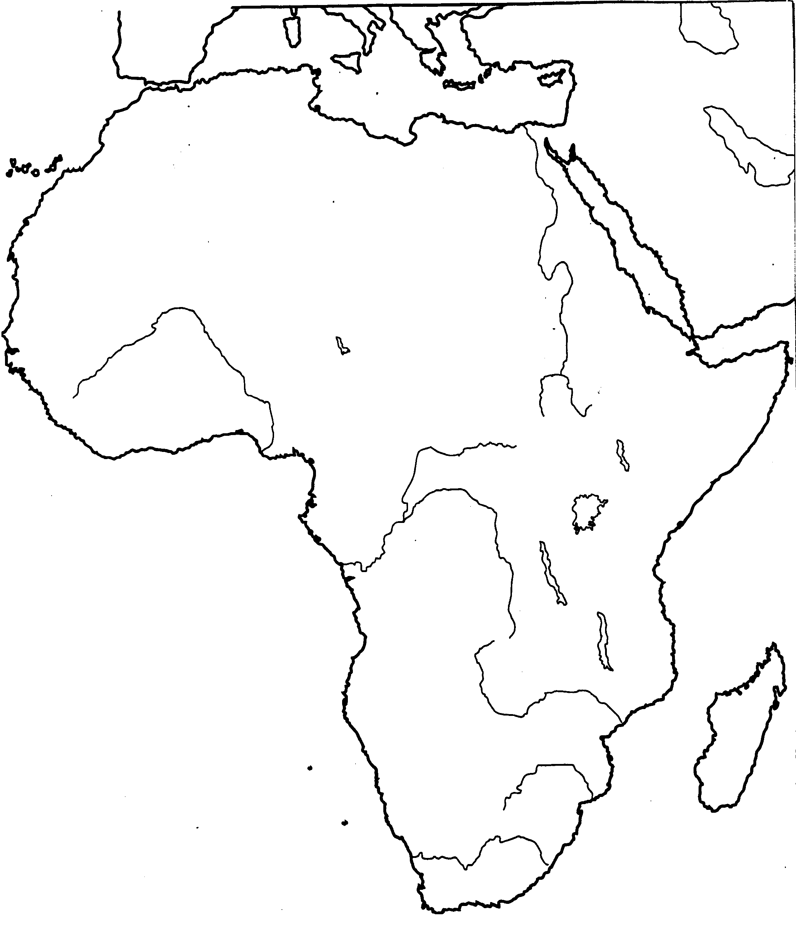

**PART III. Multiple Choice**

1. Describe the major kingdom that had control of major routes of the Trans-Saharan trade of salt and gold in 830 until c. 1235.

Ghana was founded in 800 and controlled the salt and gold trade from 830-1235.

1. Describe the fall of the empires of Ghana, Mali, and Songhai.

All three of the empires owe their success to the salt and gold trade. Trade provided power and lead to the three empires to rise. Ghana’s empire ended with a Muslim group conquering the land. Mali’s empire ended after Mansa Musa’s death and his sons couldn’t hold power. Songhai ended due to invaders and were weakened by internal political struggles that caused their decline.

1. Explain how Great Zimbabwe gained control of the gold trade.

The location of Zimbabwe was between mines and trade cities that gave it control of the trade route.

**Part IV: Primary Source**

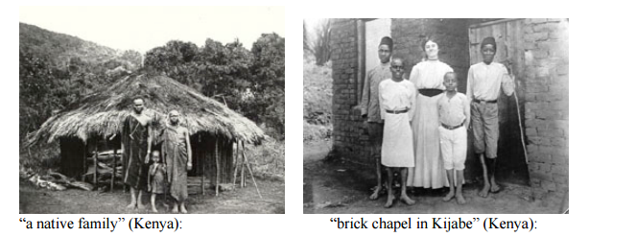

Use the primary source above to explain how European colonization impacted Africa.

**You will be expected to explain the difference between the photos and how these photos represent European’s impact on Africa.**