Welcome to Africa
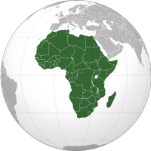
Mapping
Your job is to…
- Locate the following geographic features:
  - Mediterranean Sea
  - Red Sea
  - Atlantic Ocean
  - Indian Oceans
  - Cape of Good Hope
  - Madagascar
  - Nile River
  - Niger River
  - Congo River
  - Atlas Mountains
  - Mt. Kilimanjaro

- Locate the following kingdoms, empires, or cities:
  - Nubia
  - Great Zimbabwe
  - Aksum
  - Ghana
  - Mali
  - Songhai

- Be sure that your map has all of the TALDOGS represented in it.
  - Title (already done for you)
  - Author
  - Legend or Key
  - Date (list date published and dates map represents)
  - Orientation or Compass
  - Grid (use actual lines of latitude and longitude)
  - Scale

Materials to use include…
- World Studies textbook pages 4, 17, & 35 (Africa, Asia, & Australia)
- Colored pencils (NO markers or highlighters)

