Directions for Middle Ages Tri-Fold
Outer Flaps
- Label the title of the pamphlet with Middle Ages or Medieval Times
- Add a picture (hand-drawn or printed) that reflects this era of history

The Middle Ages

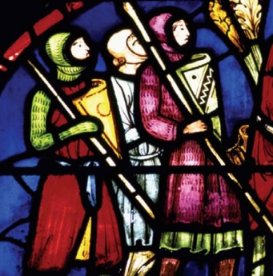

Inside Panels
- The far left panel should be titled “Basic Information.” This panel should answer the questions 1) when, 2) where, and 3) what were the Middle Ages?
- The center panel should be a diagram of the manorial system that existed during this time. This must be hand-drawn.
- The far right panel should be a diagram of the feudal order. This must be hand-drawn.
The Feudal Order

Basic Information
When?
Where?
What?
The Manorial System

