Social Studies 6 Name _______________________

Ancient Africa Date _______________________
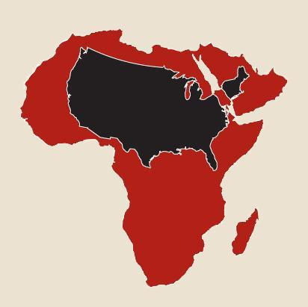
Geography of Africa
Africa is the world’s second-largest continent, with an area of almost 12 million square miles₁ By comparison, North Carolina has an area of approximately 50,000 square miles and the USA has about 4 million square miles of land. Africa is the only continent with land in all four hemispheres, since both the equator and prime meridian run through it.
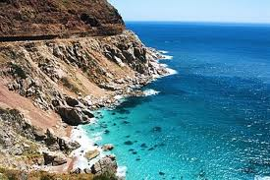
Africa is almost completely surrounded by water. The Red Sea is a long, narrow body of water on the north east corner of Africa, near the Gulf of Aden. The Mediterranean Sea is directly north of the continent and separates Africa from Europe. Oceans surround the rest of Africa. The Atlantic Ocean lies on the western side of Africa and the Indian Ocean lies to the east. Africa has few natural harbors. If you wanted to visit Africa by boat, you would have to hunt for a safe place to land. Without a safe harbor, powerful ocean currents would slam your boat into the rocks along the coastline.

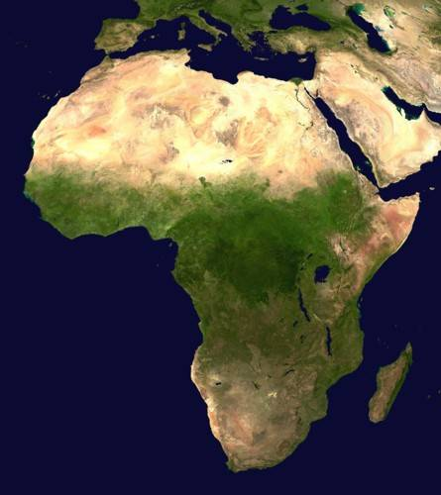
Rivers are very important to the people of Africa. They provide fish for food, fresh water for irrigation and drinking, a means of transportation₂, and hydro-electric power that is generated near waterfalls₃. The three largest rivers in Africa are the Nile in the north east, the Niger in western Africa, and the Congo in the center of the continent.
Africa is also the home to largest desert in the world, the Sahara, which stretches across the entire continent, from about 15°N to almost the northern edge of the continent₄. Some of the sand dunes in the Sahara are seven hundred feet high! The world’s fourth largest desert, the Kalahari, is located in the southwest corner of Africa₅.
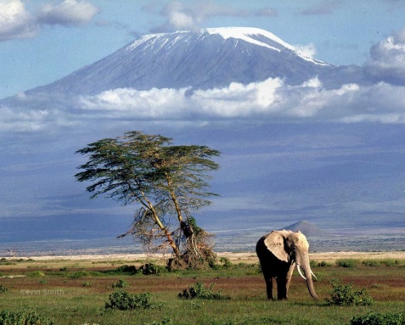
The extreme southern tip of the continent, at the point where the Atlantic and Indian Oceans meet, is called the Cape of Good Hope. On the opposite end of the African land mass are the Atlas Mountains. They can be found along the North West coast of Africa, near the Mediterranean Sea, where Africa and Europe are closest to each other. The highest point in Africa is Mount Kilimanjaro, located approximately 400 miles east of Lake Victoria. It is nearly four miles high and is ranked as the world’s highest free-standing mountain. Africa is also home to the world’s fourth largest island, Madagascar, which is found approximately 250 miles off the southeast coast, in the southern part of the Indian Ocean. With 226,000 square miles, it is over four times larger than the state of North Carolina.
A. Read the article above and pay careful attention to the description of the places written in bold text and italics. Use
the descriptions to help you decide where to write each name on the map on the back of this page. There are 13
places described in this article. Be sure to label all 13 of them on the map.

B. There are five sentences or phrases that are underlined. Each one is followed by a number from one to five. Place the
number in the table to match that sentence or phrase to one of the Five Themes of Geography.

Theme | Sentence or phrase from article (use number)  D. Write one complete sentence to summarize  the main idea of the second paragraph .  ______________________________________  ______________________________________  ____________________________________________________________________________  C. How many times could  North Carolina fit into  the continent of Africa?
Location
Place
Movement
Region
HEI

