Greek City-States

Greece is in the southeastern region of Europe₁. It is a land of mountains, surrounded on three sides by water₅, and made up of many islands. The mountains prevented large-scale farming₂ and forced the Greeks to look beyond their borders to new lands where there was fertile soil. They used their skills as great sailors to start trading₃ and develop colonies in other parts of the Mediterranean world₄.
The mountains also played an important role in the government. They provided protection for each city and discouraged the Greeks from uniting into one great country. Therefore, the Greeks developed a system of government which was based on individual cities or city- states. Two of these city-states were great rivals.
Athens
Sparta

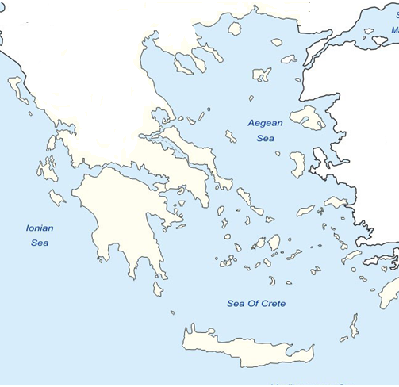
Athens
Athenians thought of themselves as the shining star of the Greek city-states. They were
famed for their literature, poetry, drama, theatre(a), schools, buildings, and government.
The Greeks believed that each city-state in ancient Greece had a god or a goddess(b) in
charge of it, their special patron. For Athens, the patron was Athena, goddess of
wisdom.
Athenians put a great deal of emphasis on education. Girls learned at home(c) from their mothers. They learned how to run a home, and how to be good wives and mothers.
Boys were educated quite differently. Until age 6 or 7, boys were taught at home by their mothers. From 7-14, boys attended a day school outside the home. There they memorized poetry and learned drama, public speaking, reading, writing, math, and music. They went on to a four year high school and learned more about math, science, and government. At age 18, they attended two years of military school.
The men of Athens met each week to discuss problems and work on solutions. Most Greek city-states were ruled by kings, but Athens was a direct democracy(d)! In Athens "rule by many" meant that all citizens had to be willing to take an active part in government. That was the law. Each year, 500 names were drawn from all the citizens of Athens. Those 500 citizens had to serve for one year as the law makers. All citizens of Athens were required to vote on any new law that this body of 500 citizens created. Women, children, and slaves were not citizens, so they could not vote.

Sparta
Sparta began as a small village, and its people believed the greatest thing a man could do with his life was to live as a proud and fierce warrior. Spartans endured unbelievable pain and hardship to become superior soldiers and citizens! When babies were born, they were examined for any weaknesses. If they appeared to be sick or weak, they were killed.

Sparta's government was ruled by a small group of warriors. The Spartans spoke Greek, wrote Greek, thought of themselves as Greeks, but they were very different from the other Greek city-states, and proud of it.

Sparta was the only city state which had a full time army. The Spartan men were well known for being brave and fierce, and they spent their whole lives training and fighting. Spartans lived in harsh conditions, without luxuries, to make them tough fighters.

Their educational system was certainly very different. The goal of Spartan education was to create a strong warrior. Boys were taken away from their parents at age 7. They lived a harsh and often brutal life in the soldier’s barracks. Younger children were beaten by older children who started fights to help make the younger boys tough and strong. Children were often whipped in front of groups of other Spartans, including their parents, but they were not allowed to cry out in pain. Sometimes boys died in these contests, without having made a sound. This would make their parents very proud. Children, during their training process, were given very little food. They were encouraged to steal food, instead. If caught stealing, they were beaten. To avoid severe pain, children learned to be cunning, to lie, to cheat, to steal, and how to get away with it! Before leaving school, a Spartan boy was expected to stalk and kill a slave to prove he was ready for war.

As adults, men did not live with their families(e). They visited their families, but men lived in soldiers’ barracks. Women, unlike women in the rest of the Greek world, had a great deal of freedom. Women were educated to be fighters. Some women became warriors. Many ran businesses(f). Life was very different in ancient Sparta than it was in the rest of ancient Greek city-states. The Spartans were proud, fierce, capable warriors. No great works of art came out of Sparta. But the Spartans, both men and women, were tough, and the Greeks admired strength.

There is a story about a young Spartan boy who had snuck away from his school. The Spartan boy caught a fox, and planned to take it back to the school to share with a couple of his classmates. Suddenly, he saw a group of soldiers approaching him, and he tucked the fox under his shirt to hide it. The soldiers stopped him and asked him if he had anything to eat. The boy lied (as good Spartan boys were taught to do) and said no. The fox began chewing through his stomach. The boy did not cry or give any indication of what the fox was doing. The soldiers went on. If the soldiers had realized he was lying they would beat him severely; not for lying but for getting caught lying.

Questions:
1. What geographic feature kept the Ancient Greeks separated into city-states instead
of united into one country? ________________________________________

2. Why did the Greeks “look beyond” Greece to colonies in other parts of the
Mediterranean Region? ________________________________________
________________________________________
3. Complete the chart comparing Athens & Sparta. Place at least one fact in each box.

Athens | Sparta
Government: | Government:
Education: | Education:
Treatment of Girls and Women: | Treatment of Girls and Women:
Army: | Army:
4. There are 14 words or phrases in the reading that are bold and underlined – match
each with its synonym listed below:

Synonym | Bold word or phrase from reading | Synonym | Bold word or phrase  from reading
productive |  | suggestion
withstand |  | area
enemies |  | coming closer
supporter |  | smart
harsh |  | joining
peninsula |  | archipelago
settlements |  | importance

5. Draw an appropriate flag for each city-state:
Athens Sparta

6. Read each quote below, then write “A” if you think an Athenian would have said it or
“S” if a Spartan would have said it.

_____ Mother to son going off to war: “If you can’t come back a winner, don’t come back at all”.
_____ Teacher to students: “Each day we will do word exercises to sharpen your mind and physical
exercises to tone up your body”.
_____ Citizen to friend: “Don’t you agree, all citizens should serve on juries.”
_____ Teacher to students: “Shoes soften your feet. The rule here is everyone goes barefoot”.
_____ Government leader to assistant: “That baby is a weakling. Throw him in that hole”!

7. During the Olympics, one of these city-states won a lot more events than the other.
On the lines below, tell which city-state you think won the most events and explain
why you think that city-state was more successful.
____________________________________________________________
____________________________________________________________
____________________________________________________________
____________________________________________________________
____________________________________________________________
____________________________________________________________
9. In the paragraphs about Athens and Sparta you
will see the letters a-f following some words.
Each letter marks an example of one of the
Culture Patterns. Place the letter next to the
correct pattern :

Family
Education
Art
Religion
Politics
Economics

8. In the first paragraph, you will see
the numbers 1-5 following some words.
Each number marks an example of one of
the Five Themes of Geography. Place the
number next to the correct theme:
Location
Place
Movement
Region
HEI

