**GREEK PHILOSOPHERS**

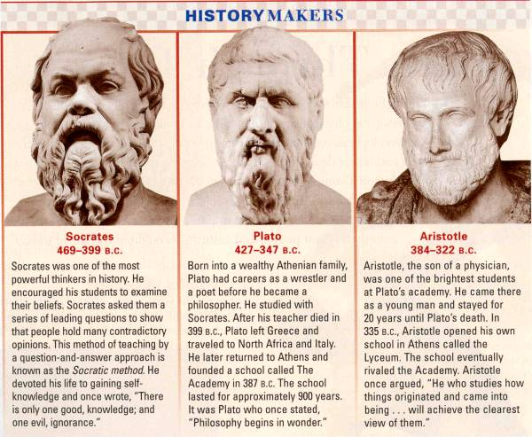

**Plato**

After Socrates died, his student Plato carried on his work. Plato was a great writer. His most famous book is The Republic. It is still read today.

In The Republic, Plato wrote down his ideas about government. Plato did not believe that democracy was the best kind of government. He did not believe that most people could make good decisions about

government. Instead, Plato believed that a small group of wise men should run the government.

**Aristotle**

The last great philosopher of Athens was Aristotle. He was a student of Plato. Aristotle was a brilliant man who explored all areas of learning. He wrote hundreds of books on science, government, philosophy, and other subjects. His books had a great **influence**, or effect, on later scientists.

**Looking Back**

1. How did the Greeks believe they could find

answers to questions about the world?

2. What is the Socratic method?

3. What did Plato write about government in The Republic?

4. Use context clues to define:

Philosophers-

Observation –

Ethics –

Influence –

How did the world begin? What is the

right way for people to live?

Most ancient people thought that only the

gods could answer such questions. But many

Greeks thought differently. They believed

people themselves could answer such

questions through reason. They believed

people could use their minds to answer

questions about the world and human beings.

The Greeks called people who searched for

such answers **philosophers**, or ''lovers of

knowledge.” Greek philosophers made

important contributions to the growth of

modern science and philosophy.

Their method of finding answers through

careful **observation** (study) was used by later

scientists and philosophers.

**Socrates**

Some philosophers were interested in

**ethics**, or ideas about the right way to live.

One of those philosophers was Socrates.

Socrates was a teacher who lived in

Athens. He taught that people must learn to

think for themselves. Only through clear

thinking could people discover the right wav

to live.

Socrates taught his students to think clearly

by asking them questions. When Socrates was

not satisfied with an answer, he asked more

questions. That method of teaching by asking

questions became known as the Socratic

Method.

Socrates urged his students to question all

their old beliefs. Some Athenians thought

such teaching was dangerous. They accused

Socrates of turning his students away from the

gods. Socrates was put on trial. A jury found

Socrates guilty. His penalty was death. In 399

B.C., Socrates drank a cup of poison and died.



**GREEK DRAMA**

**Tragedy and Comedy**

At first, Greek plays were tragedies. A **tragedy** is a story of great suffering. The ending is always sad. The greatest Greek tragedies were written by three Athenians: Aeschylus, Sophocles, and Euripides. Later, the Greeks created another kind of play. It was called a **comedy**. Comedies were filled with jokes about daily life. They had happy endings. The best comedies were written by an Athenian named Aristophanes.

**Looking Back**

1. How did Greek drama develop?

2. How were plays performed?

3. How were tragedies and comedies different?

4. Use context clues to define:

Chorus -

Chanted –

Tragedy –

Comedy -

During the Golden Age of Athens, the

Greeks invented a new form of art. It was

called drama. In this new art form, people

acted out stories. Drama grew out of the

Athenian festival for Dionysus, the god of wine.

During the festival, a **chorus**, or group of

singers, sang and **chanted** (spoke together)

stories about Dionysus.

About 500 B.C., an important change took

place at the festival. One member of the

chorus was chosen to act out part of the

story. Later, other actors were added. The

stories became what we call plays.

**Greek Theaters**

Greek dramas were performed outdoors.

Theaters were built on hillsides to give

everyone a good view. Some theaters held

10.000 people. Often, several plays were

performed one after another. People brought

food and wine to theaters and stayed all day.

Three actors performed all the parts in a

Greek drama.

The actors wore masks that looked like the

character they were playing. The masks were

large so that they could be seen by everyone

in the huge theaters. The chorus played an

important role in the drama. It sang or chanted

some of the story.