Placemat Directions
Suggested Web Sites:
http://www.unicef.org/statistics/index_countrystats.html
http://www.nationmaster.com/
http://www.who.int/gho/countries/en/
http://www.internetworldstats.com/stats.htm

- Quadrants & Map - Fold your placemat into 4 quadrants (4 parts). Cut out the map (at the bottom of the page) and glue it to the center of your placemat. If you MUST have a color version, you can print one at home. (This doc is posted on the homepage of the Weebly.)
- Countries – Label each quadrant with a country below:
  - Ethiopia (Sub-Saharan Africa region)
  - China (Eastern Asia region)
  - India (Southern Asia region)
  - Turkey (Middle Eastern/Mediterranean region)
- Find the Basics - For each country, provide the following present-day information:
  - Language (mostly spoken)
  - Major Religion(s)
  - Major Cities and/or Provinces
  - Population of the country
  - 2 cultural images (hand-drawn, cut from magazines, or computer-printed)
- Statistics - As you circulate through the “regions” during Spartan Time, record interesting information for each. Provide two (2) statistics about the region. Statistics can include crime rate, literacy rate, population, Internet usage, GDP, and infant mortality rate, just to name a few! (See the back for definitions and other ideas.)
- #SalemProud – When all other tasks have been completed, you may add some additional fun facts to your placemat to make it special to you. You may choose any or all of the choices below:
  - List out interesting customs of the region
  - Translate a few simple greetings or sayings into the main language of the region
  - Show the currency and exchange rate
  - List out foods made popular by this region
  - Name and explain a major historical event
  - Write out a law from this country that is very different from American law
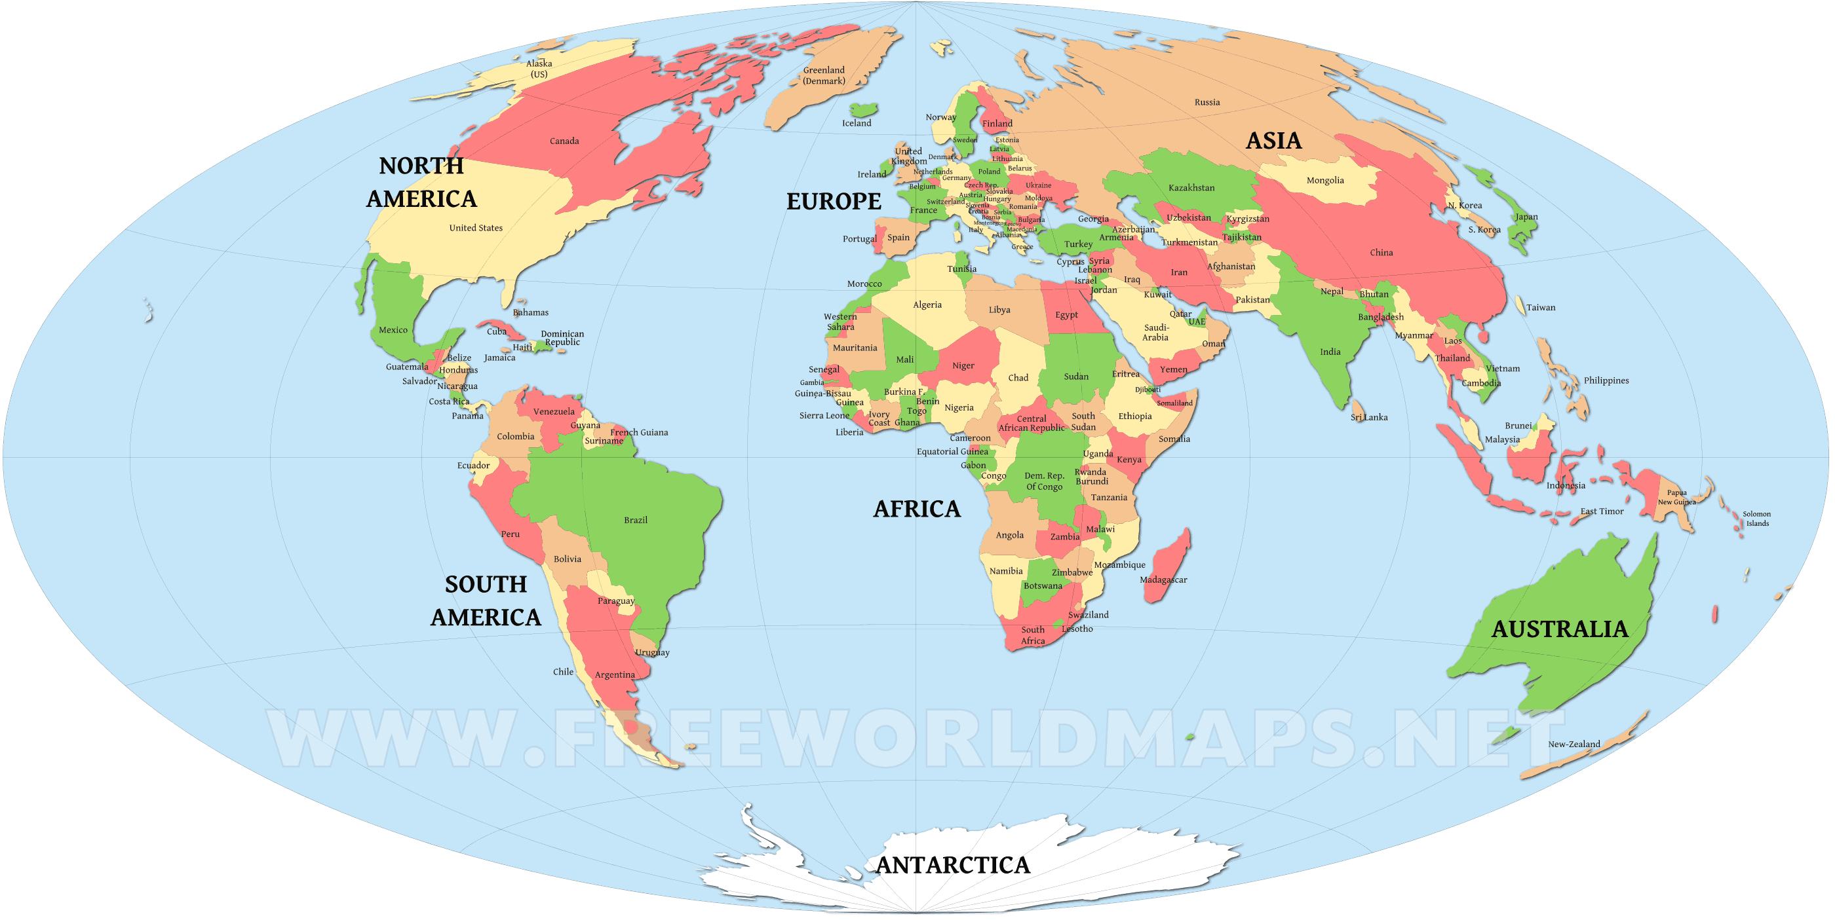

Key Term | Definition
Region | An area or division, especially part of a country or the world having definable characteristics but not always fixed boundaries.
Population density | A measurement of population per unit area or unit volume; it is a quantity of type number density. It is frequently applied to living organisms, and particularly to humans.
GDP (Gross Domestic Product) | Gross Domestic Product (GDP) is the broadest quantitative measure of a nation's total economic activity. More specifically, GDP represents the monetary value of all goods and services produced within a nation's geographic borders over a specified period of time.
Crime rate | The number of offenses per 100,000 population, is derived by first dividing a jurisdiction's population by 100,000 and then dividing the number of offenses by the resulting figure.
Literacy rate | Literacy rate refers to the percentage of people who are able to read and write vs. those who are not.
Infant mortality rate | The infant mortality rate is the number of deaths under one year of age occurring among the live births in a given geographical area during a given year, per 1,000 live births occurring among the population of the given geographical area during the same year.
Currency | A system of money in general use in a particular country.
Exchange rate | The value of one currency for the purpose of conversion to another.
Customs | A traditional practice or usual way of doing something followed by a social group or people.
Internet usage | The measurement (expressed in bytes, kilobytes, megabytes or gigabytes) of the amount of data flowing through your computer and the Internet network for a defined period.

