India Flocabulary Discussion Questions
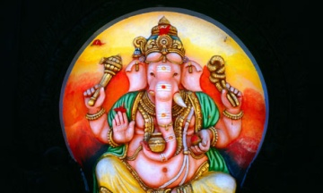
- What mountain range protected India from invaders? ________________________________

- What were the twin cities of the Indus Valley? ____________________________________

- Who were the warlike people who "hit 'em up" like Tupac? _________________________________

- What written language did the Aryans use to write the Vedas? ___________________________

- Who were the priestlike figures in the Aryan culture? _____________________

- What were the occupations of the Vaishya caste? ____________________________________

- What is the Hindu process in which the soul is believed to be reborn into different bodies? ___________

- Where was Siddhartha sitting upon finding peace? ____________________________

- According to the beliefs of Buddhism, where is heaven located? ____________________________

- Buddha says, "The mind is everything. What we think, we ______________."

- Describe the caste system.

- Would you rather be a Brahmin or an untouchable? Explain why.

- What do you think the chorus, ‘It goes round and round, is talking about?
It goes round and round,
Till it all comes back again.’

India Flocabulary Discussion Questions
- What mountain range protected India from invaders? ________________________________

- What were the twin cities of the Indus Valley? ____________________________________

- Who were the warlike people who "hit 'em up" like Tupac? _________________________________

- What written language did the Aryans use to write the Vedas? ___________________________

- Who were the priestlike figures in the Aryan culture? _____________________

- What were the occupations of the Vaishya caste? ____________________________________

- What is the Hindu process in which the soul is believed to be reborn into different bodies? ___________

- Where was Siddhartha sitting upon finding peace? ____________________________

- According to the beliefs of Buddhism, where is heaven located? ____________________________

- Buddha says, "The mind is everything. What we think, we ______________."

- Describe the caste system.

- Would you rather be a Brahmin or an untouchable? Explain why.

- What do you think the chorus, ‘It goes round and round, is talking about?
It goes round and round,
Till it all comes back again.’

