**http://www.enchantedlearning.com/crafts/memory/timeline/timeline.GIFIslamic Expansion Review Guide**

Name: ______________________________

Core: _______ Date: ___________________

**Part 1: Timeline** *(1 point each)*  
1-5. Complete the timeline below by plotting the dates in the correct order. Then, answer the multiple choice questions below based on the timeline. Be sure to place the events in the correct sequence according to the basic principles of a timeline.

700 CE

800 CE

600 CE

400 CE

500 CE

1. _____________ – Muhammad dies. Islam spreads across Southwest Asia and North Africa.
2. _____________ – Muhammad leave Mecca for Medina. Marks the beginning of Islamic calendar.
3. _____________ – Angel appears and tells Muhammad to spread the word of God.
4. _____________ – Muhammad begins to spread his message.
5. _____________ – Muhammad is born.

How long has Islam been in existence? Show your work. ____________________________________________________

How long did Muhammad live? Show your work. _______________________________________________

**Part 2: Map** *(1 point each)*Draw 5 conclusions about Islamic Expansion based on the map.

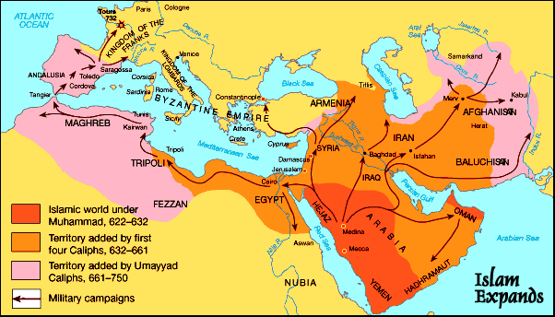

1.

2.

3.

4.

5.

**Part 3: Basic Knowledge** *(1 point each)*

Match the word to its meaning.

Arabia__________________________________________________________________

Mecca__________________________________________________________________

Quran or Koran___________________________________________________________

Mosque_________________________________________________________________

Muslim__________________________________________________________________

Islam____________________________________________________________________

C:\Documents and Settings\Administrator\Local Settings\Temporary Internet Files\Content.IE5\YM28U9BX\MC900156537[1].wmf______________________________________________________________________

**Part 4: Split of Islam** *(1 point each)*Read the text (on the separate sheet of paper) and answer the following questions.

What is the main idea of the text? __________________________________________________________________________________________________

What are the differences between the two main groups?

________________________________________________________________________________________________________________________________________________________________________________________________

What are the two leaders that are elected by the different groups? ____________________ and _________________

What does the map say about Sunnis and Shiites in the Middle East? __________________________________________________________________________________________________