Social Studies 6 Name ____________________________
Ancient Japan Unit Date _____________________________

Geography of Ancient Japan
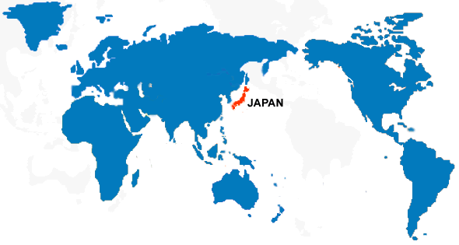
Japan, located off the East coast of Asia, is an archipelago nation comprised of four main islands and over 3,500 smaller islands. Japan stretches over 2,360 miles from north to south, so the people enjoy climatic variety. If it were to be superimposed on the eastern United States, Japan would stretch from central Maine to Florida. In contrast, its width from east to west is barely 200 miles, about the same distance from Raleigh to the Outer Banks and Atlantic Ocean.
Its proximity, or nearness, to China has caused cultural diffusion between these nations to occur frequently₅.

Landforms and Climate
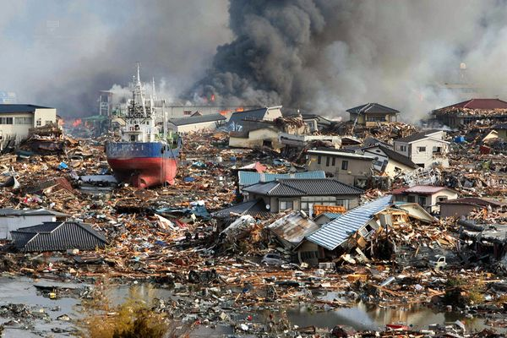
Japan’s four main islands include Hokkaido, the northernmost island and Kyushu, the southernmost. In between are the largest (Honshu) and the smallest (Shikoku) islands. On the main island of Honshu, at 35N˚, 138˚E, is Mt. Fuji, an active volcano that has not erupted since 1707. The Japanese considered Mt. Fuji to be a sacred site, and it became a symbol of the nation₄. Today it is a tourist destination and is popular with mountain climbers. Across the Sea of Japan is the Korean Peninsula₂, which today is the home of the nations of North Korea and South Korea.
The northern section of Japan has a climate similar to the northern states of the USA₁; summers are cool and winters are long and cold with much snowfall. The southern section, such as Kyushu and the Ryukyu Islands has a subtropical climate, with mild winters and very hot, humid summers. Heavy rain and typhoons frequently cause flood damage on these islands.₃ Japan also experiences many natural disasters, due to its location along the “Ring of Fire”, a fault line beneath the Pacific Ocean. Earthquakes are very common, and occasionally an underwater earthquake will create a tsunami - a huge and destructive wave.
Results of a tsunami – March 2011

Bodies of Water
As an island nation, Japan is surrounded by water on all sides. To the west is the Sea of Japan and to the east is the Pacific Ocean. South of Japan is the Philippine Sea. The northernmost island, Hokkaido is bordered to the north by the Sea of Okhotsk. Located just west of the Korean Peninsula is the Yellow Sea. The Korean Peninsula is also home to three important rivers. Forming the border with China is the Yalu River; while the Taedong River can be found in the north and the Han River in the south. The longest and most important river in Japan, the Shinano River, can be found on west coast of the island of Honshu.

A. Label the map -- Read the article above and pay careful attention to the description of the places written in bold text
and italics. Use the descriptions to help you decide where to write each name on the map on the back of this
page. There are 15 places described in this article. Be sure to label all 15 of them on the map.

B. Five Themes Chart: There are five phrases that are underlined. Each one is followed by a number from one to five.
D. Match the synonym to one of the seven bold,
underlined words from the reading.
Synonym/Definition | Word from reading
1. very holy
2. difference
3. storms
4. once in a while
5. made up of
6. laid over
7. target or goal
Place the number in the table to match that sentence or phrase to one of the Five Themes of Geography.

Theme | Sentence or phrase from article (use number)  C. Fill in the blanks –  An archipelago nation is made up of many _______.  Besides Japan, _________ was another archipelago nation we studied this year.
Location
Place
Movement
Region
HEI

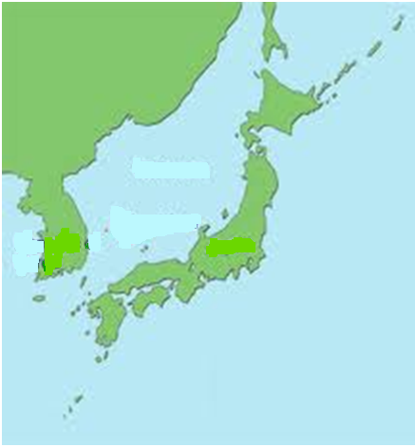
How wide is Japan at 40°N?

________miles

How wide is Korea at 40°N?

________miles

F...
Check these off as you add them to the map.

Shinano River
Yalu River
Taedong River
Han River

Philippine Sea
Sea of Japan
Sea of Okhotsk
Pacific Ocean
Yellow Sea

Honshu
Hokkaido
Kyushu
Shikoku
Mt. Fuji
Korean Peninsula

40°N
A
N

S
W
E
= river’s mouth

Sakhalin Island
(Russia)
150°E
130°E
140°E
= current border of
North Korea and
South Korea

30°N

0 200 miles
China

E. Map Questions:
1. On the map above, what does the dotted line represent? _______________________________________________

2. What is the distance from the mouth of the Taedong River to the mouth of the Han River? _________miles

3. What is the distance from Point A to Mount Fuji? _________miles

4. Kyushu is (NE, SE, NW, SW) of Shikoku.

5. Hokkaido is (NE, SE, NW, SW) of Korea

6. Which is the best estimate for the absolute location of the Shinano River’s mouth? (37°N, 138°E) or (43°N, 142°E)

7. Estimate the absolute location of Shikoku - ___________________________

8. Estimate the absolute location of Point A - ___________________________

9. Use a range of numbers to describe the absolute location of the entire nation of Japan: (____ - ____°N, ____ -_____°E)

10. Write a complete sentence to describe the relative location of Sakhalin Island - ______________________________

________________________________________________________________________________________________

11. Explain what is meant by the phrase climatic variety in the first paragraph. ___________________________________

________________________________________________________________________________________________

