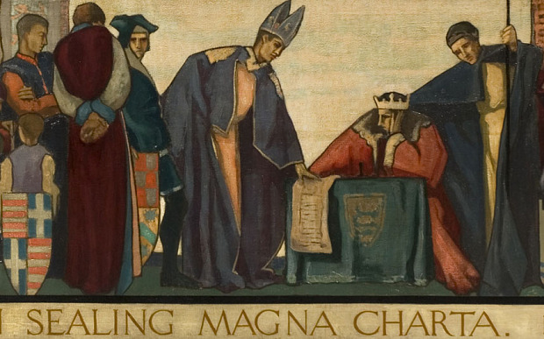
King John & the Magna Carta
King John was an English king. He was not a very pleasant person. He told lies. He put innocent people in prison so that he could steal their belongings. He put a poor man in prison once just so he could steal the man's horse and cart.
There was a rumor that he murdered his nephew, but it was never proved. The King of France demanded to know where the boy was. King John was a vassal of the King of France. That meant he had to answer. But he did not respond to the King of France.
Promises never bothered King John. He would promise anything to anybody, especially if there was money in it for him, but he soon broke his word.
When the archbishop of Canterbury died, King John seized the monastery, banished all the monks, and kept the land and the wealth for himself.
This made the archbishop furious. The archbishop called all the nobles together and read the law of the land to them. He made sure they understood their rights under the law. Some could not read, and many did not know their rights. The nobles were amazed to discover that King John was breaking the law, and that they could do something about it.
The nobles confronted King John. King John promised he would do better. He promised the nobles that he would raise taxes again without discussing it first. After all, it was the law.
In truth, however, the law had as much value to King John as did his word. Weeks later, he raised taxes again without consulting anyone. He had two of his nobles arrested, and seized their lands, without allowing them to present any defense.
The nobles were furious. Armed and ready, they gathered a huge force of nobles at the town of Runnymede. They brought the king there. The archbishop read aloud to the king from a parchment he held, a parchment called the Magna Carta, the Great Charter.
As the king listened, he became more and more angry. How dare his nobles treat him like this? How dare the archbishop read from a piece of paper and except him to sign it? It was clear, even to selfish King John, that if he did not sign, his nobles would desert him. Without an army behind him, some pretender would soon steal his throne. The king was furious about it, but he signed the Magna Carta.
The Magna Carta was a list of rights. Most rights were already law. The Magna Carta stated them again so there would be no confusion. Plus, the Magna Carta added new rights. One of the new rights was that nobles could keep watch over the king. They could seize his castles if he did not keep his word.
Some historians say that after signing the Magna Carta, King John went home in a huff, and screamed, and rolled around on the floor like a madman. Perhaps he did. But it did not matter. From that day on, things changed in England forever. The king could no longer do whatever he wanted. He had to obey the law just like everyone else. If he did not, his nobles could seize his lands and banish him from England.
Name 3 significant facts about King John and the Magna Carta that all kids should remember.
- ___________________________________________________________________________________________
- ___________________________________________________________________________________________
- ___________________________________________________________________________________________

