Later Civilizations of the Americas
Name: ____________________________________
Date: ______________________ Core: _________
PART A: Locate on a map and explain significance
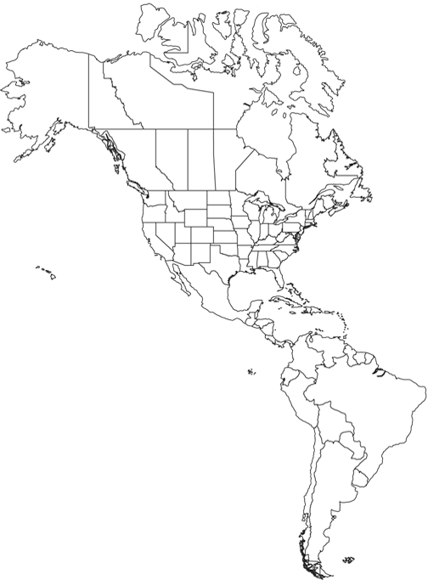
1. Andes Mountains
The Incans set up their civilization there.
2. Yucatan Peninsula
The Mayans set up their civilization
there.
3. Tenochtitlan
2
The Aztecs set up their civilization here.
(Mexico City today)
3
4. Machu Picchu
4
This is the most well-known city of the Incan civilization
that is still standing today.
1

Part B: Match to description of person
5. Conquistadors
Spanish explorers that conquered the Americas
6. Hernan Cortes
Spanish conquistador who conquered the Aztec empire in 1521.
7. Francisco Pizarro
Spanish conquistador who conquered the Incan empire.
8. Quetzalcoatl
The creator god for the Aztecs

PART C: Multiple choice of description
9. Polytheistic
the belief in many gods; the Mayas, Incas, and Aztecs were all polytheistic
10. Diseases
these were brought over by the Europeans and were part of the reason the Europeans were able to conquer the Mayan, Incas, and Aztecs
11. Mayan Calendar
The highly accurate calendar developed by the Mayans after studying the sky for centuries, noticing the movement of the sun, moon, and planets.

12. Pre-Contact or Pre-Colonization
The time period BEFORE the Columbian Exchange began and explorers found the western hemisphere.

