Martin Luther

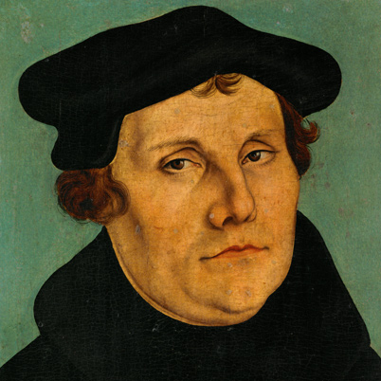
On a fateful afternoon while caught out in a storm, Martin Luther was nearly struck by lightning. He felt that this was a sign that he should give up law school and become a monk.

Shortly thereafter Martin Luther joined a monastery in Germany, and began to dedicate his life to learning and teaching the Gospel. The more he studied, the more he felt that the Catholic Church had gone astray. He collected a list of 95 different points of doctrine where he felt that the Church was incorrect.

On October 31, 1517, Martin wrote these 95 points of doctrine on a placard, which he nailed to the door of the Catholic Church in Wittenberg, Germany. These 95 points of doctrine were copied and sent throughout Germany, resulting in the Catholic Church losing out on the collection of money that it collected in exchange for indulgences. The sale of indulgences was one of the 95 practices that Martin Luther disagreed with. This practice allowed people to buy forgiveness for their sins.

As the money from the sale of indulgences greatly declined, Pope Leo X grew upset and sent convoys to Martin Luther in an attempt to get him to recant his disagreement. Martin Luther refused to do so, stating that he had an obligation to God to do what he felt was right.
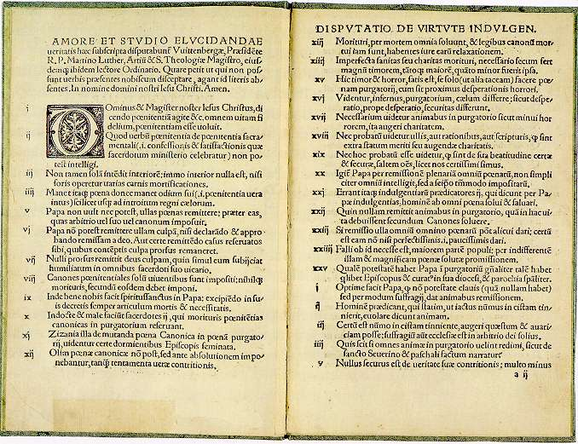
By 1520 A.D., the Catholic Church and Pope Leo X had had enough. They declared Martin Luther a heretic, a crime punishable by death. Luther escaped and went into hiding, where he translated the Bible into German.

Citing the Waldensians as an example of a Christian church that was separate from Catholicism, Martin Luther founded a new religion known as Lutheranism.

