Meet Mansa Musa I of Mali – the richest human being in all history

A new study has produced an inflation-adjusted list of the richest people of all time John Hall
Tuesday 16 October 2012
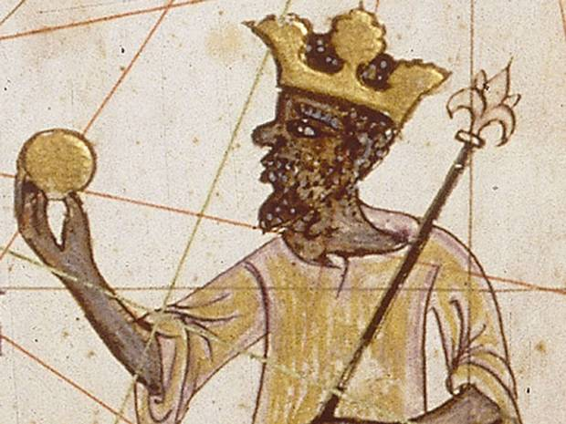
When we think of the world’s all-time richest people, names like Bill Gates, Warren Buffet and John D Rockefeller immediately come to mind.
But few would have thought, or even heard of, Mansa Musa I of Mali – the obscure 14th century African king who was today named the richest person in all history.
With an inflation adjusted fortune of $400 billion, Mansa Musa I would have been considerably richer than the world’s current richest man, Carlos Slim, who ranks in 22nd place with a relatively paltry $68 billion.
The list, compiled by the Celebrity Net Worth website, ranks the world’s 24 richest people of all time. The list advertises itself as the top 25, but 26 names appear in the list.
Although the list spans 1000 years, some aspects of wealth appear consistent throughout history; there are no women on the list, only three members are alive today, and 14 of the top 25 are American.
The list uses the annual 2199.6 per cent rate of inflation to adjust historic fortunes – a formula that means $100 million in 1913 would be equal to £2.299.63 billion today.
Mansa Musa I ruled West Africa’s Malian Empire in the early 1300s, making his fortune by exploiting his country’s salt and gold production. Many mosques he built as a young man still stand today.
After Mansa Musa I death in 1331, however, his heirs were unable to hang on to the fortune, and it was substantially depleted by civil wars and invading armies.
Second on the list are the Rothschild family, whose descendants are still among the richest people on the planet. Starting out in banking in the late 18th Century, Mayer Amschel Rothschild’s finance house accumulated a total wealth of $350 billion. The money has since been divided between hundreds of descendants, many of whom are business leaders today.
Meanwhile John D. Rockefeller, third on the list, is the richest American to have ever lived, worth $340billion in today's USD at the time of his death in 1937.
In comparison, the poorest man on the list is 82-year-old Warren Buffett, who at his peak net worth, before he started giving his fortune to charity, was $64billion.

Here’s the full list of the ‘26 richest people of all time’:
1. Mansa Musa I, (Ruler of Malian Empire, 1280-1331) $400 billion
2. Rothschild Family (banking dynasty, 1740- ) $350 billion
3. John D Rockefeller (industrialist, 1839-1937) $340 billion
4. Andrew Carnegie (industrialist, 1835-1919) $310 billion
5. Tsar Nicholas II of Russia (last Emperor of Russia, 1868-1918) $300 billion
6. Osman Ali Khan, Asaf Jah VII (last ruler of Hyderabad, 1886-1967) $236 billion
7. William the Conqueror (King of England, 1028-1087) $229.5 billion
8. Muammar Gaddafi (former Libyan leader, 1942-2011) $200 billion
9. Henry Ford (Ford Motor Company founder, 1863-1947) $199 billion
10. Cornelius Vanderbilt (industrialist, 1794-1877) $185 billion
11. Alan Rufus (Fighting companion of William the Conqueror, 1040-1093) $178.65 billion
12. Bill Gates (Founder of Microsoft, 1955- ) $136 billion
13. William de Warenne, 1st Earl of Surrey (Norman nobleman, ??-1088) $146.13 billion
14. John Jacob Astor (businessman, 1864-1912) $121 billion
15. Richard Fitzalan, 10th Earl of Arundel (English nobleman, 1306-1376) £118.6 billion
16. John of Gaunt (son of Edward III, 1330-1399) £110 billion
17. Stephen Girard (shipping and banking mogul, 1750-1831) $105 billion
18. Alexander Turney Stewart (entrepreneur, 1803-1876) $90 billion
19. Henry, 1st Duke of Lancaster (English noble, 1310-1361) $85.1 billion
20. Friedrich Weyerhaeuser (timber mogul, 1834-1914) $80 billion
21. Jay Gould (railroad tycoon, 1836-1892) $71 billion
22. Carlos Slim (business magnate, 1940- ) $68 billion
23. Stephen Van Rensselaer (land owner, 1764- 1839) $68 billion
24. Marshall Field (Marshall Field & Company founder, 1834-1906) $66 billion
25. Sam Walton (Walmart founder, 1918-1992) $65billion
26. Warren Buffett (investor, 1930- ) $64billion

