Name ___________________________ Core ____________ Date _____________
Mesopotamia Reading Questions (M)
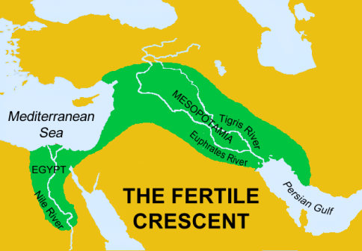

The Fertile Crescent
Explain what and where the Fertile Crescent is, what is unique about it, and where is it located today.
________________________________________________________________________________________________________________________________________________________________________________________________________________________________________________________________________________________________________________________________________________________________________

The Sumerians
Match the word from the Sumerian section to its synonym/definition found in the section:
Word from Sumerian Section | Synonym/Definition | Word from Sumerian Section | Synonym/Definition
Conquered |  | Polytheistic
Civilization |  | Hemisphere
Domesticate |  | Nomads
Irrigation |  | Ziggurats
City-state |  | Monotheism

Use 4 adjectives to describe the Sumerians: _____________, _____________, _____________, ____________

Civilization
Most civilizations must have what four elements?
Element | Description

Numbering Years
- In ancient calendars how were years numbered? _______________________________________________
- Define the following terms:
AD: __________________
BC: __________________
CE: __________________
BCE: _________________

- There are ______ years in a decade, ____________ years in a century, and ___________ years in a millennium.
- Is there a year 0? _________
Gilgamesh
- What is Gilgamesh? ______________________________________________________________________
- What does it tell? ________________________________________________________________________
- What is it similar to? _____________________________________________________________________

Hammurabi
Who was Hammurabi? _______________________________________________________________________
List 2 things that Hammurabi did:
- ____________________________________________________________________________________
- ____________________________________________________________________________________

The Assyrians
Summarize the Assyrians in a short paragraph (3-5 sentences). Do not copy the text directly.
__________________________________________________________________________________________________________________________________________________________________________________________________________________________________________________________________________________________________________________________________________________________________________________________________________________________________________________________________

Reflection Questions

How did geographic features in Mesopotamia impact development of civilizations and people's adaptation to their environment?
__________________________________________________________________________________________________________________________________________________________________________________________________________________________________________________________________________________________________________________________________________________________________________________________________________________________________________________________________

- Give examples of important advances in society that were started in Mesopotamia (Think communication, food, building)
____________________________________________________________________________________________________________________________________________________________________________________

