Ancient Americas Research Stations
Name: ______________________________
Core: _____
Date: ___________________
Station # | Topic/Activity | Notes/Details
1 | Religious Beliefs (using computers)  Task: Go to the website listed and tell characteristics of each civilizations religious beliefs. | M - http://mayas.mrdonn.org/religion.html
 |  | I - http://incas.mrdonn.org/religion.html
 |  | A - http://aztecs.mrdonn.org/place.html
2 | Historical Maps  Task: Find the map of each civilization. In the table, shade in its area on the mini map and explain (with words/text) WHERE these civilizations were located. Remember to use RELATIVE LOCATION. | Maya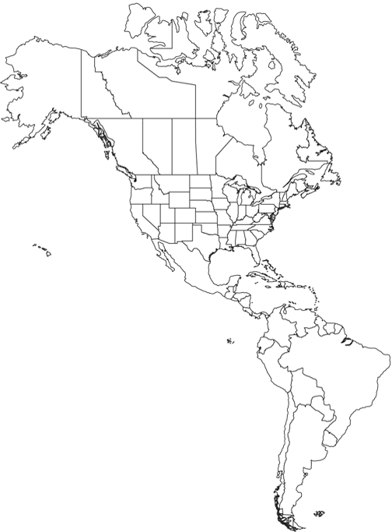  Description of location: | Inca  Description of location: | Aztec  Description of location:
3 | Language/  Communication  Task: Using the texts provided, explain the types of communication that were used in each civilization. Did they have a written or phonetic language? Describe what they each had. | M
 |  | I
 |  | A
4 | Folktales/Myths  Task: Read the different folktales and pull clues that tell what each civilization valued, believed, and honored. | M
 |  | I
 |  | A
5 | Artifact Photos  Task: Look at the photographs of the artifacts and draw conclusions about what the civilizations felt about violence, art, and religion. | M
 |  | I
 |  | A
6 | Archaeological City/State Design  Task: Look closely at the pictures provided. Explain what you see in the development of their towns and road systems. What is similar to what we have today? Explain. | M
 |  | I
 |  | A
7 | Jobs/Skills  Task: Read the texts available. Determine what types of jobs and skills the different cultures specialized in. Did the environment or physical geography play a role in which jobs they had? If so, how? | M
 |  | I
 |  | A

