1. Siddhartha Gautama searched for wisdom in many ways.  2. The teachings of Buddhism deal with finding peace.  3. Buddhism spread far from where it began in India.  Buddhism began in India and became a major religion.  Key Terms  fasting  meditation  nirvana  missionaries  As you read, use the interactive graphic organizer to record information on the basic ideas of Buddhism and on Buddhism’s spread.  Interactive Graphic Organizer |  | Origins of Buddhism  If YOU lived there…  You are a trader traveling in northern India in about 520 BC. As you pass through a town, you see a crowd of people sitting silently in the shade of a huge tree. A man sitting at the foot of the tree is speaking about how one ought to live. His words are like nothing you have heard from the Hindu priests.  Will you stay to listen? Why or why not?  BUILDING BACKGROUND The Jains were not the only ones to break from Hinduism. In the 500s BC a young Indian prince attracted many people to his teachings about how people should live.  Siddhartha’s Search for Wisdom  In the late 500s BC a restless young man, dissatisfied with the teachings of Hinduism, began to ask his own questions about life and religious matters. In time, he found answers. These answers attracted many followers, and the young man’s ideas became the foundation of a major new religion in India.  The Quest for Answers  The restless young man was Siddhartha Gautama (si-DAHR-tuh GAU-tuh-muh). Born around 563 BC in northern India near the Himalayas, Siddhartha was a prince who grew up in luxury. Born a Kshatriya, a member of the warrior class, Siddhartha never had to struggle with the problems that many people of his time faced. However, Siddhartha was not satisfied. He felt something was missing in his life.  Siddhartha looked around him and saw how hard most people had to work and how much they suffered. He saw people grieving for lost loved ones and wondered why there was so much pain in the world. As a result, Siddhartha began to ask questions about the meaning of human life.

The Great Departure

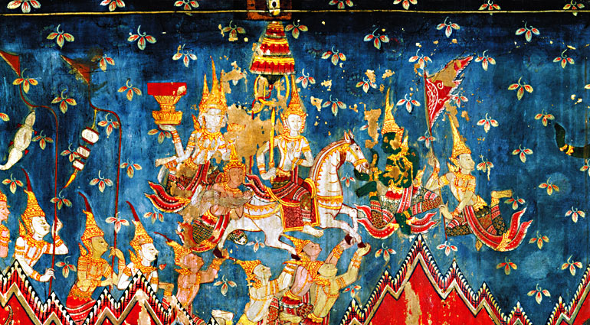

In this painting, Prince Siddhartha leaves his palace to search for the true meaning of life, an event known as the Great Departure. Special helpers called ganas hold his horse’s hooves so he won’t awaken anyone.

Before Siddhartha reached age 30, he left his home and family to look for answers. His journey took him to many regions in India. Wherever he traveled, he had discussions with priests and people known for their wisdom. Yet no one could give convincing answers to Siddhartha’s questions.

The Buddha Finds Enlightenment
Siddhartha did not give up. Instead, he became even more determined to find the answers he was seeking. For several years, he wandered in search of answers.
Siddhartha wanted to free his mind from daily concerns. For a while, he did not even wash himself. He also started fasting, or going without food. He devoted much of his time to meditation, the focusing of the mind on spiritual ideas.
According to legend, Siddhartha spent six years wandering throughout India. He eventually came to a place near the town of Gaya, close to the Ganges River. There, he sat down under a tree and meditated. After seven weeks of deep meditation, he suddenly had the answers that he had been looking for. He had realized that human suffering comes from three things:

• | wanting what we like but do not have,
• | wanting to keep what we like and already have, and
• | not wanting what we dislike but have.

Siddhartha spent seven more weeks meditating under the tree, which his followers later named the Tree of Wisdom. He then described his new ideas to five of his former companions. His followers later called this talk the First Sermon.
Siddhartha Gautama was about 35 years old when he found enlightenment under the tree. From that point on, he would be called the Buddha (BOO-duh), or the “Enlightened One.” The Buddha spent the rest of his life traveling across northern India and teaching people his ideas.

Teachings of Buddhism
As he traveled, the Buddha gained many followers. Many of these followers were merchants and artisans, but he even taught a few kings. These followers were the first believers in Buddhism, the religion based on the teachings of the Buddha.
The Buddha was raised Hindu, and many of his teachings reflected Hindu ideas. Like Hindus, he believed that people should act morally and treat others well. In one of his sermons, he said
“Let a man overcome anger by love. Let him overcome the greedy by liberality [giving], the liar by truth. This is called progress in the discipline [training] of the Blessed.”
–The Buddha, quoted in The History of Nations: India
Four Noble Truths
At the heart of the Buddha’s teachings were four guiding principles. These became known as the Four Noble Truths:

1. | Suffering and unhappiness are a part of human life. No one can escape sorrow.
2. | Suffering comes from our desires for pleasure and material goods. People cause their own misery because they want things they cannot have.
3. | People can overcome their desires and ignorance and reach nirvana, a state of perfect peace. Reaching nirvana would free a person’s soul from suffering and from the need for further reincarnation.
4. | People can overcome ignorance and desire by following an eightfold path that leads to wisdom, enlightenment, and salvation.

The chart at the bottom of this page shows the steps in the Eightfold Path. The Buddha believed that this path was a middle way between human desires and denying oneself any pleasure. He believed that people should overcome their desire for material goods. They should, however, be reasonable, and not starve their bodies or cause themselves unnecessary pain.

The Eightfold Path
This giant statue of the Buddha is just south of the town of Gaya in Bodh Gaya, India—the place where Buddhists believe Siddhartha reached enlightenment.

Challenging Hindu Ideas
Some of the Buddha’s teachings challenged traditional Hindu ideas. For example, the Buddha rejected many of the ideas contained in the Vedas, such as animal sacrifice. He told people that they did not have to follow these texts.
The Buddha challenged the authority of the Hindu priests, the Brahmins. He did not believe that they or their rituals were necessary for enlightenment. Instead, he taught that it was the responsibility of each person to work for his or her own salvation. Priests could not help them. However, the Buddha did not reject the Hindu teaching of reincarnation. He taught that people who failed to reach nirvana would have to be reborn time and time again until they achieved it.
The Buddha was opposed to the caste system. He didn’t think that people should be confined to a particular place in society. He taught that every person who followed the Eightfold Path properly would reach nirvana. It didn’t matter what varna or caste they had belonged to in life as long as they lived the way they should.
The Buddha’s opposition to the caste system won him the support of the masses. Many herders, farmers, artisans, and untouchables liked hearing that their low social rank would not be a barrier to their enlightenment. Unlike Hinduism, Buddhism made them feel that they had the power to change their lives.
The Buddha also gained followers among the higher classes. Many rich and powerful Indians welcomed his ideas about avoiding extreme behavior while seeking salvation. By the time of his death around 483 BC, the Buddha’s influence was spreading rapidly throughout India.

Early Spread of Buddhism

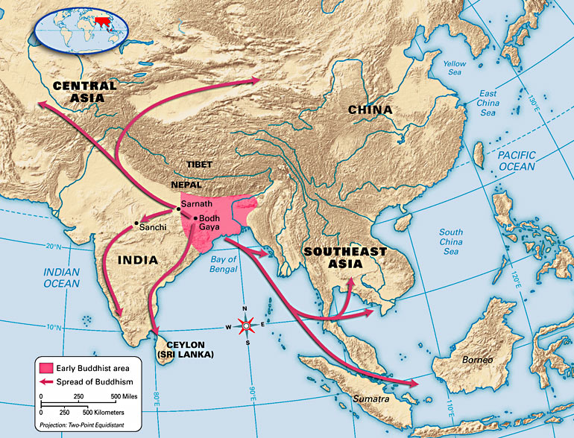

Young Buddhist students carry gifts in Sri Lanka, one of the many places outside of India where Buddhism spread.

Movement After the Buddha died, his teachings were carried through much of Asia.

Buddhism Spreads
Buddhism continued to attract followers after the Buddha’s death. After spreading through India, the religion began to spread to other areas as well.

Buddhism Spreads in India
According to Buddhist tradition, 500 of the Buddha’s followers gathered together shortly after he died. They wanted to make sure that the Buddha’s teachings were remembered correctly.
In the years after this council, the Buddha’s followers spread his teachings throughout India. The ideas spread very quickly, because Buddhist teachings were popular and easy to understand. Within 200 years of the Buddha’s death, Buddhism had spread through most of India.

Buddhism Spreads beyond India
The spread of Buddhism increased after one of the most powerful kings in India, Asoka, became Buddhist in the 200s BC. Once he converted, he built Buddhist temples and schools throughout India. More importantly, though, he worked to spread Buddhism into areas outside of India. You will learn more about Asoka and his accomplishments in the next section.
Asoka sent Buddhist missionaries, or people who work to spread their religious beliefs, to other kingdoms in Asia. One group of these missionaries sailed to the island of Sri Lanka around 251 BC. Others followed trade routes east to what is now Myanmar and to other parts of Southeast Asia. Missionaries also went north to areas near the Himalayas.
Missionaries also introduced Buddhism to lands west of India. They founded Buddhist communities in Central Asia and Persia. They even taught about Buddhism as far away as Syria and Egypt.
Buddhism continued to grow over the centuries. Eventually, it spread via the Silk Road into China, then Korea and Japan. Through their work, missionaries taught Buddhism to millions of people.

A Split within Buddhism
Even as Buddhism spread through Asia, however, it began to change. Not all Buddhists could agree on their beliefs and practices. Eventually, disagreements between Buddhists led to a split within the religion. Two major branches of Buddhism were created—Theravada and Mahayana.
Members of the Theravada branch tried to follow the Buddha’s teachings exactly as he had stated them. Mahayana Buddhists, though, believed that other people could interpret the Buddha’s teachings to help people reach nirvana. Both branches have millions of believers today, but Mahayana is by far the larger branch.

