China’s Growing Urban Population Sprouts Urban Farms
December 22, 2011 by Robin Plaskoff Horton
Source: http://www.urbangardensweb.com/2011/12/22/chinas-growing-urban-population-sprouts-urban-farms/

In response to its growing urbanization, China is reinventing the “garden city” concept in order to create space for both its urban and its displaced rural citizens. Every year, more than 15 million people move from the countryside to the cities. By 2025, China is expected to have 400 million more people living in its cities. To feed the world’s largest population, China will have to explore novel ways of food production.

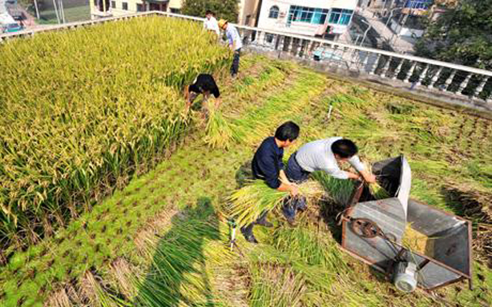
Harvesting rice on a 120-square-meter rooftop paddy. Photo: Feature China/Barcroft Media.

As displaced rural communities are forced into the cities, urban planners have begun to analyze an emerging trend, the merging of country and city by preserving patches of space to be used as productive farmland within urban boundaries.

The model could bring back work and purpose for displaced farmers, but also reduce food miles, meaning access to more fresh agricultural products at lower costs and a decrease in carbon emissons. This reduction in air pollution would be very helpful for the people of China. As a bonus, urban farmland could also be showcased for “agrotourism” and used for education.
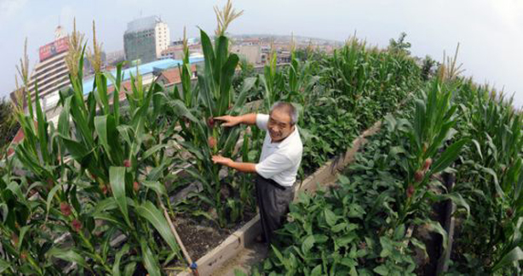
At the grassroots level, the concept is already in practice. Zhang Guichun, a 55-year old resident of Beijing, farms an organic “hanging garden” on the roof of his traditional courtyard home north of Tian Tan in southern Beijing.
“Even if we don’t have enough land in the city, agriculture can go vertical, up to roof and balcony,” Zhang notes.
Zhang, who practices traditional Chinese medicine, began cultivating his hanging garden five years ago and now grows about 3o varieties of vegetables and fruits, including tomatoes, cucumbers, sweet bell peppers, and melons, and now harvests enough to feed his entire family.
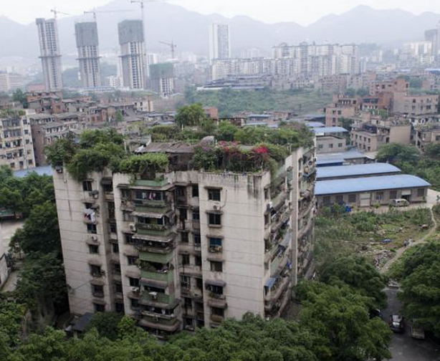
In addition to supplying his family with safe and nutritious food, Zhang’s vertical rooftop farm offers many other tangible benefits. The garden keeps his home cooler in the summer, reduces the number of mosquitoes as tomatoes are natural insect repellents, and he has cultivated more than veggies: he has bonded with neighbors.“Neighbors,” explains Zhang, “enjoy dropping by for a relaxing chat or just to see how well the lovely vegetables and fruit are doing.”

