THE QURAN
Islam appeared in the form of a book: the Quran. Muslims, consider the Quran (sometimes spelled "Koran") to be the Word of God as transmitted by the Angel Gabriel, in the Arabic language, through the Prophet Muhammad. The Muslim view, moreover, is that the Quran supersedes earlier revelations; it is regarded as their summation and completion. It is the final revelation, as Muhammad is regarded as the final prophet - 'the Seal of the Prophets."
In a very real sense the Quran is the mentor of millions of Muslims, Arab and non-Arab alike; it shapes their everyday life, anchors them to a unique system of law, and inspires them by its guiding principles. Written in noble language, this Holy Text has done more than move multitudes to tears and ecstasy; it has also, for almost fourteen hundred years, illuminated the lives of Muslims with its eloquent message of uncompromising monotheism, human dignity, righteous living, individual responsibility, and social justice. For countless millions, consequently, it has been the single most important force in guiding their religious, social, and cultural lives. Indeed, the Quran is the cornerstone on which the edifice of Islamic civilization has been built.
http://www.islamicity.com/mosque/ihame/Ref1.htm /// http://www.al-islam.org/short/quraanlessons.htm

Respecting the Qu’ran:
1. A part of the Qur’aan carries the same respect as the entire Qur’aan. Allah says: When the Qur’aan is recited, listen to it (7:204).
2. The Qur’aan should always be carried with proper care. When your bag contains the Qur’aan, or a part of it, take extra care of the bag. Keep the bag slowly on the desk or floor instead of letting it fall on its own. Use both hands to remove the Qur’aan from your bag, kiss the cover of the Qur’aan, place it slowly on a desk (or on a wooden carrier specially built for holding the Qur’aan) and open the pages gently.
3. When the Qur’aan is being recited, listen to it and be attentive (7:204). If you are busy with something else then at least do not disturb the recitation by talking, for example, or making noise.
4. The Qur’aan should be recited regularly. It is disrespect to keep the Holy Qur’aan unread. Prophet Muhammad (s) said: Brighten your homes with reciting Qur’aan; do not turn them into graves. Surely the house in which a lot of recitation takes place enjoys many blessings and the members benefit from it. Such a household shines for the inhabitants of Heaven as stars shine to the inhabitants of the earth.
5. Children should get familiarized with the Qur’aan early in their lives.
6. It is the right and respect of the Qur’aan that it should be followed. It is also the right and respect of the Qur’aan that those who have the knowledge of the Qur’aan should teach it to others. This is among the noblest acts. Prophet Muhammad (s) said: The best of you is he who learns the Qur’an and teaches it.
Questions to discuss:
- What language is the Qu’ran written in? Why do you think it can only be written in this language?
- Who is the primary author of the Qur’an?
- What does the Qu’ran teach Muslims about day-to-day living?
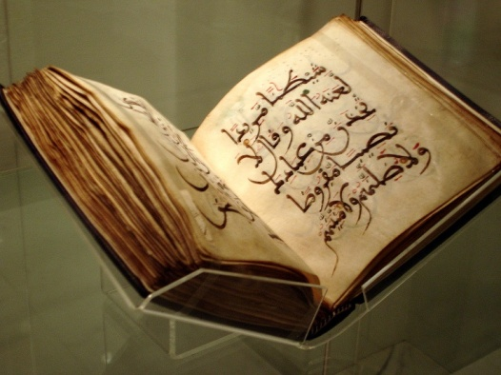
- Why do Muslims respect and cherish the Qu’ran so much?
