The Fertile Crescent
Directions: Use the reading and map on page 320 in the red book to label and color the following locations on the map below.
Physical Features: Tigris River Euphrates River Nile River Red Sea
Political Features: Fertile Crescent (label and shade)
Ancient Egypt Mesopotamia
Babylon Sumer
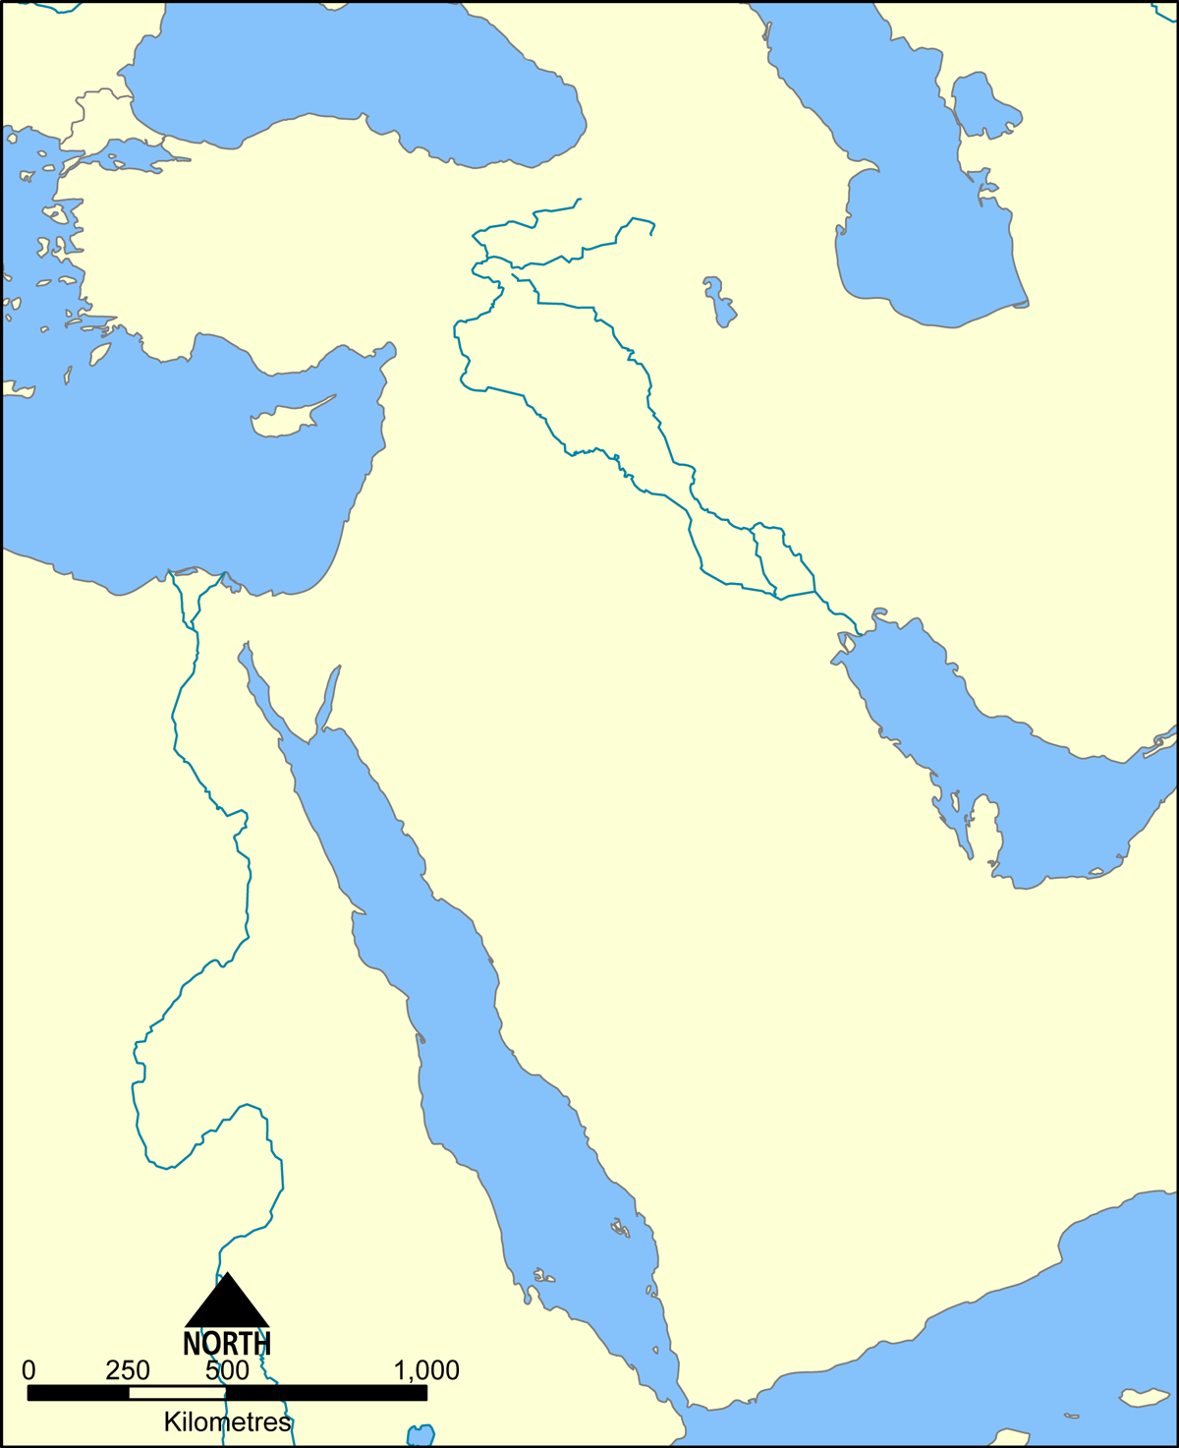
Analysis Questions
1. Which physical feature south of Mesopotamia would discourage human settlement? WHY?
2. How does the name “Mesopotamia” represent the region?
3. What major similarity do you see between the region of Mesopotamia and Ancient Egypt?

4. “Mesopotamia was the world’s first great civilization.” Using support from the text, why would someone make this statement?

