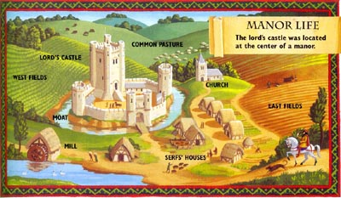
The Medieval Manor
The basic economic unit of feudal times was the manor. A manor was the estate of a lord and consisted of all his land and the people he controlled. These people were his knights, and the serfs who worked his land. Some manors were large, while others were quite small.
The focal point of the manor was the castle or manor house of the lord. Clustered around the lord’s home were the huts of the peasants, a mill, and a variety of other craft shops. A large manor might have a miller, a carpenter, a blacksmith, and various other tradesmen. The services these workers provided made the estate self-sufficient. Most manors also had a small church where the village priest addressed the daily needs of the manor’s inhabitants.
Part of the lord’s land was used as meadow and common pasture, but most was reserved for farming. At the time, farming involved a three-field system of cultivation. One field was planted in the spring, and a second was planted in the fall. To keep the three fields were plots that the serfs used as their own. Although the plots technically belonged to the serfs, the lord took his share of what was grown and raised there, including pigs, chickens, and livestock.
The lord of the manor, along with his family and any knights in attendance, performed no labor. They were sustained by the labor of the serfs, who toiled long hours under wretched conditions. Only on Sundays and feast days were the serfs allowed any rest from their grueling work.
Respond to each prompt with complete sentences.

- Describe the layout of a typical manor.
____________________________________________________________________________________________________________________________________________________________________________________________________________________________________________________________________________________________________________________________________________________________________________________________
- What made a manor self-sufficient?
______________________________________________________________________________________________________________________________________________________________________________________________
- Explain the three-field system of cultivation.
______________________________________________________________________________________________________________________________________________________________________________________________
- Why weren’t the serfs plots truly their own?
______________________________________________________________________________________________________________________________________________________________________________________________
©2000 McDonald Publishing Co.

