Name _______________________
Period _______________________
Ancient Americans Vocabulary

Vocabulary Word | Definition | Picture
Culture | The set of learned beliefs, values, styles, and behaviors generally shared by members of a society or group | 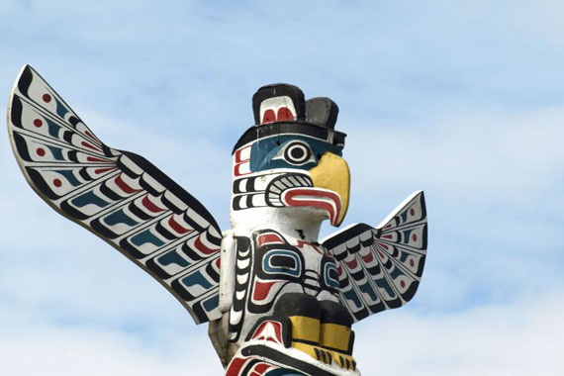
Bering Land Bridge | A land bridge roughly 1,000 miles wide (north to south) which joined present-day Alaska and eastern Siberia at various times during an ice age | 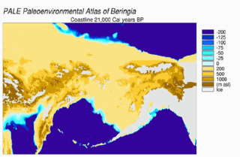
Matrilineal Descent System | A lineage system where membership in a group is inherited from one's mother | 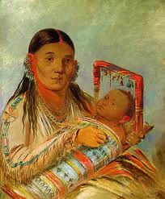
Civilization | A society with complex social hierarchies and organized, institutional governments | 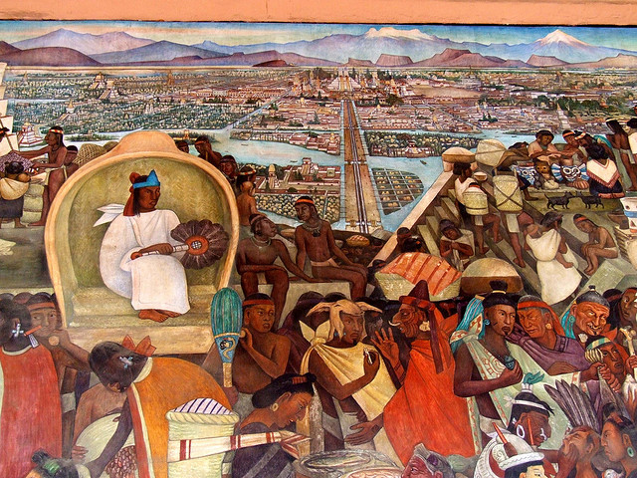
Indigenous | The native population of a region | 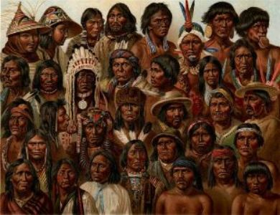
Columbian Exchange | Exchange of culture, peoples, plants, animals, and diseases between the “Old World” (Eastern Hemisphere) and the “New World” (Western Hemisphere) | 

